**CHAPTER 1**

**INTRODUCTION**

Agriculture has seen many revolutions, whether the domestication of animals and plants a few thousand years ago, the systematic use of crop rotations and other improvements in farming practice a few hundred years ago, or the “green revolution” with systematic breeding and the widespread use of man-made fertilizers and pesticides a few decades ago. Agriculture is undergoing a fourth revolution triggered by the exponentially increasing use of information and communication technology (ICT) in agriculture. Autonomous, robotic vehicles have been developed for farming purposes, such as mechanical weeding, application of fertilizer, or harvesting of fruits.

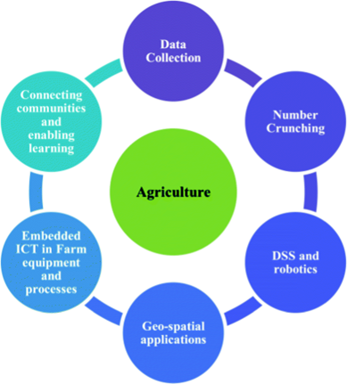

**Fig: 1.1 Agriculture and ICT innovation**

The development of unmanned aerial vehicles with autonomous flight control, together with the development of lightweight and powerful hyperspectral snapshot cameras that can be used to calculate biomass development and fertilization status of crops, opens the field for sophisticated farm management advice. Moreover, decision-tree models are available now that allow farmers to differentiate between plant diseases based on optical information.

* 1. **PROBLEM STATEMENT**

Farmers face significant crop losses due to wildlife intrusions, especially organic farmers who can't use chemical controls. Traditional methods like fencing or night guarding are often unsafe or ineffective. Animal tracks, crop damage, and faeces indicate varying levels of contamination risk. A smarter, safer solution is needed to protect crops without harming wildlife. AIoT (Artificial Intelligence for IoT) offers a tech-based approach to monitor and prevent such intrusions.

**ARTIFICIAL INTELLIGENCE**

An AI is a computer system that is able to perform tasks that ordinarily require human intelligence. These artificial intelligence systems are powered by machine learning. Many of them are powered by machine learning, some of them are powered by specifically deep learning, some of them are powered by very boring things like just rules.

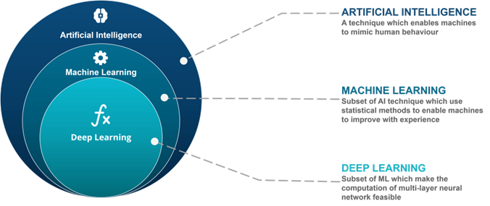

**Fig: 1.2 Artificial Intelligence**

**Machine Learning in a Nutshell**

Machine learning allows experts to “train” a machine by making it analyze massive datasets. The more data the machine analyzes, the more accurate results it can produce by making decisions and predictions for unseen events or scenarios. Machine learning models need structured data to make accurate predictions and decisions. If the data is not labeled and organized, machine learning models fail to comprehend it accurately, and it becomes a domain of deep learning.

**Deep Learning in a Nutshell**

The deep learning methodology designs a sophisticated learning model based on neural networks inspired by the human mind. These models have multiple layers of algorithms called neurons. They continue to improve without human intervention, like the cognitive mind that keeps improving and evolving with practice, revisits, and time. Deep learning models are mainly used for classification and feature extraction. For instance, deep models feed on a dataset in facial recognition.

**CONVOLUTIONAL NEURAL NETWORK – WildNet Model**

A Convolutional Neural Network (ConvNet/CNN) is a Deep Learning algorithm that can take in an input image, assign importance (learnable weights and biases) to various aspects/objects in the image, and be able to differentiate one from the other. The pre-processing required in a ConvNet is much lower as compared to other classification algorithms. While in primitive methods filters are hand-engineered, with enough training, ConvNets have the ability to learn these filters/characteristics. The architecture of a ConvNet is analogous to that of the connectivity pattern of Neurons in the Human Brain and was inspired by the organization of the Visual Cortex.

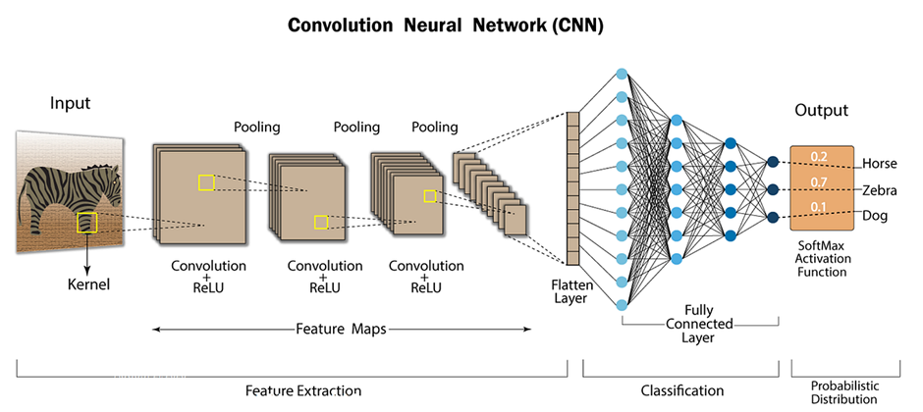

**Fig: 1.3 Convolutional Neural Network**

**Convolutional Layer + Relu**

This layer is the first layer that is used to extract the various features from the input images. In this layer, the mathematical operation of convolution is performed between the input image and a filter of a particular size MxM.

**Pooling Layer**

In most cases, a Convolutional Layer is followed by a Pooling Layer. The primary aim of this layer is to decrease the size of the convolved feature map to reduce computational costs. This is performed by decreasing the connections between layers and independently operating on each feature map.

**Fully Connected Layer**

The Fully Connected (FC) layer consists of the weights and biases along with the neurons and is used to connect the neurons between two different layers. These layers are usually placed before the output layer and form the last few layers of a CNN Architecture.

**Activation Functions**

Finally, one of the most important parameters of the CNN model is the activation function. They are used to learn and approximate any kind of continuous and complex relationship between variables of the network.

**TEMPORAL CONVOLUTIONAL NETWORKS**

The seminal work of Lea et al. (2016) first proposed a Temporal Convolutional Networks (TCNs) for video-based action segmentation. The two steps of this conventional process include: firstly, computing of low-level features using (usually) CNN that encode spatial-temporal information and secondly, input these low-level features into a classifier that captures high-level temporal information using (usually) RNN. TCN model has two layers, i.e., a dilated causal convolution and non-linearity (ReLU), as well as weight normalization in between. In addition, a spatial dropout was added after each dilated convolution for regularization, and an additional 1×1 convolution was adopted to ensure that the element-wise addition ⊕ received tensors of the same shape.

* 1. **AIM AND OBJECTIVE**

The aim of the project is to develop an integrated wildlife defence system utilizing AI computer vision and ultrasound emissions technology to effectively detect, repel, and mitigate animal intrusions in agricultural environments, thereby reducing crop damage and increasing agricultural productivity.

* To implement AI computer vision algorithms for real-time animal detection and species recognition.
* To integrate species-specific ultrasound emissions to deter identified animals from agricultural fields.
* To design a user-friendly interface for farmers to monitor and manage the wildlife defense system.
* To develop alert mechanisms to notify farmers of potential wildlife intrusions via SMS or other means.
* To evaluate the effectiveness and efficiency of the integrated system through field trials and performance analysis.
* To provide scalable and adaptable solutions to address varying wildlife-related challenges in agriculture.
* To enhance agricultural productivity and minimize crop damage caused by wildlife intrusions through proactive defense measures.
  1. **SCOPE OF THE PROJECT**

This project aims to develop AI-based animal detection algorithms using computer vision for real-time identification of wildlife in agricultural fields. It involves deploying machine learning models to analyze images or video streams and accurately detect animals. The system integrates species-specific ultrasound emitters to deter identified animals, offering a non-invasive defense against intrusions. A user-friendly interface will allow farmers to configure the system, monitor detections, and receive SMS alerts for timely intervention.

**Key Elements in Scope**

1. **Wildlife Detection and Classification**
   * Develop and train a **deep learning model** (e.g., YOLO, SSD) to detect and classify different animal species (e.g., boars, elephants, deer, etc.).
   * Use annotated wildlife datasets or custom field data to improve model accuracy in local environments.
2. **Edge Computing Integration**
   * Deploy trained models on **edge devices** (like Raspberry Pi, NVIDIA Jetson Nano, etc.) for real-time inference.
   * Edge computing enables processing close to the data source (camera), reducing latency and dependency on internet connectivity.
3. **Real-Time Alert and Deterrent Mechanism**
   * On detecting wildlife, trigger **automated deterrent systems** (lights, sound alarms, sprinklers).
   * Send real-time alerts to farmers via **SMS, mobile app, or IoT dashboards**.
4. **Environmental Adaptability**
   * Include adaptability features like adjusting detection sensitivity based on **weather, time of day, and animal activity patterns**.
   * Implement a feedback loop to improve the model’s performance over time based on new sightings or false positives.
5. **Power-Efficient and Scalable Design**
   * Optimize the system for **low power consumption**, ensuring feasibility in rural areas.
   * Design the system to be **modular and scalable** for deployment
   * across varying field sizes and terrains.
6. **Data Logging and Analytics**
   * Log detection data (animal type, time, location) for **trend analysis** and **wildlife behavior prediction**.
   * Support for integrating analytics dashboards for decision-makers and authorities.

**7. Environmental Data Fusion**

* Combine animal detection with:
  + **Weather data** (e.g., rain, fog)
  + **Soil moisture**
  + **Time of day/season**
* Adjust system sensitivity or deterrent strategy accordingly.

**8. Data Logging, Visualization & Reporting**

* Store logs of:
  + Animal intrusions (with timestamps and images)
  + Triggered deterrents
  + False alarms
* Generate **daily, weekly, or monthly reports** for:
  + Wildlife patterns
  + Deterrent effectiveness
  + Crop damage correlation
  + Triggered deterrents

**9. Security & Fail-Safe Mechanisms**

* + Tamper-proof hardware enclosure
  + Alert if device is disconnected or sabotaged
  + Backup battery in case of power outage

**CHAPTER 2**

**LITERATURE SURVEY**

1. **Title: Workflow and convolutional neural network for automated identification of animal sounds**

**Authors:** Zachary J.Ruff, Damon B.Lesmeister, Cara L.Appel, Christopher M.Sullivan  **Year:** 2021

**Link:** https://www.sciencedirect.com/science/article/pii/S1470160X21000844

**Objective**

To develop an efficient deep learning-based system for automated detection of forest-adapted birds and mammals from acoustic data, reducing manual processing time and making detection accessible to field researchers.

**Summary**

This study introduces a deep convolutional neural network for classifying spectrograms from short audio clips to detect 14 forest species. Integrated into a multi-step workflow, it drastically reduces human effort by over 99% while maintaining accuracy. A user-friendly Shiny-based GUI in RStudio allows field biologists to process recordings near the point of collection using standard computers, enabling rapid and efficient acoustic monitoring in wildlife research.

1. **Title: Real-Time Monitoring of Agricultural Land with Crop Prediction and Animal Intrusion Prevention using Internet of Things and Machine Learning at Edge**

**Authors:** R. Nikhil; B.S. Anisha; Ramakanth Kumar P **Year: 2020**

**Link:** https://ieeexplore.ieee.org/document/9198508

**Objective**

To design a smart agriculture system integrating IoT, automation, and ultrasonic deterrents to optimize irrigation, predict crops, and prevent wild animal intrusions in an eco-friendly and cost-effective manner.

**Summary**

The proposed smart agriculture system automates irrigation based on soil moisture, predicts suitable crops through soil analysis, and deters wild animals using ultrasonic buzzers. It enhances farming efficiency by conserving water, guiding crop selection, and safeguarding fields without harming the ecosystem. This IoT-driven solution offers a sustainable, low-energy, and user-friendly approach to addressing key challenges in modern agriculture.

1. **Title: Animal Behaviour Prediction with Long Short-Term Memory**

**Authors:** Henry Roberts; Aviv Segev **Year:** 2020

**Link:** https://ieeexplore.ieee.org/document/9378184

**Objective**

To develop an efficient pipeline using machine learning, particularly LSTM networks, for building accurate and predictive behavioral models of animals from large-scale video data.

**Summary**

This study addresses the gap in comprehensive animal behavioral models by proposing a machine learning pipeline that leverages vast online video data. It uses LSTM networks trained on JAABA-annotated frames to predict animal behavior, outperforming traditional time-series models like ARIMA. The approach reduces manual effort and enhances the accuracy and practicality of behavioral modeling in ethological research.

1. **Title: IoT based animal classification system using convolutional neural network**

**Authors:** L. G. C. Vithakshana; W. G. D. M. Samankula **Year:** 2020

**Link:** https://ieeexplore.ieee.org/document/9313018

**Objective**

To develop an IoT-based acoustic animal classification system using CNN and MFCC for remote ecosystem monitoring**.**

**Summary**

This study presents an IoT-enabled acoustic classification system utilizing Convolutional Neural Networks (CNN) for identifying animal species based on sound. Addressing the limitations of visual methods, it uses Mel Frequency Cepstral Coefficients (MFCC) to preprocess audio clips and trains a CNN using TensorFlow. The system was tested with 400 two-second audio samples across 10 animal species, offering an efficient tool for researchers in environmental and zoological fields.

1. **Title: Animal Sound Classification Using Dissimilarity Spaces**

**Authors:** Loris Nanni , Sheryl Brahnam , Alessandra Lumini and Gianluca Maguolo **Year:** 2020

**Link:** https://www.researchgate.net/publication/347555377_Animal_Sound_Classification_Using_Dissimilarity_Spaces

**Objective**

To classify animal vocalizations using Siamese networks and dissimilarity spaces, with an ensemble of SVMs to improve classification accuracy.

**Summary**

This article introduces a method for animal vocalization classification by leveraging four Siamese networks and dissimilarity spaces generated through supervised and unsupervised clustering techniques. The system projects patterns into these dissimilarity spaces, followed by classification using SVMs, with results combined by sum rule. Experimental results show that the ensemble approach outperforms individual models, offering improved performance..

1. **Title: The Monkeys Are Coming – Design of Agricultural Damage Warning System by IoT-based Objects Detection and Tracking**

**Authors:** Kuei-Chung Chang; Zi-Wen Guo **Year:** 2018

**Link:** https://ieeexplore.ieee.org/document/8448434

**Objective**

To develop an IoT-based system for detecting Taiwan Macaques and preventing agricultural damage by alerting farmers and driving the monkeys away.

**Summary**

This article introduces an IoT-based system to detect Taiwan Macaques entering farm fields and alert farmers through notifications while using noise to drive the monkeys away. The system sends sensing data and images to a server for further analysis, offering an effective solution to prevent agricultural damage. The MQTT-based architecture enables easy system extension, making it highly useful for farmers facing increasing macaque-related crop losses in Taiwan.

1. **Title: IoT Solutions for Crop Protection Against Wild Animal Attacks  
   Authors**: S. Giordano, I. Seitanidis, M. Ojo, D. Adami, and F. Vignoli

**Year:** 2018  
**Link:** <https://ieeexplore.ieee.org/document/8379183>

**Objective**  
To design and implement an IoT-based system aimed at protecting crops from wild animal attacks by using a network of smart sensors and deterrent devices. The system seeks to minimize crop losses through early detection and timely intervention, while offering farmers a low-maintenance, scalable, and automated solution suitable for diverse agricultural environments. It also aims to improve real-time monitoring and response through efficient communication and edge processing capabilities.

**Summary**  
This paper presents an IoT-enabled approach to safeguarding agricultural fields from wild animals. The proposed system employs a network of sensors to detect intrusions and activates appropriate deterrent mechanisms—such as sound or light—to repel animals. The architecture includes edge computing capabilities to reduce latency and improve real-time responsiveness. Communication among devices is managed through wireless protocols, ensuring flexible deployment and scalability. Field tests demonstrated the system’s effectiveness in reducing crop damage, offering a cost-efficient and autonomous solution suitable for remote or rural agricultural settings.

**CHAPTER 3**

**EXISTING SYSTEM**

Traditionally, farmers have employed various methods to repel animals from their crops and livestock. While these methods may lack the sophistication of modern AI-based systems, they have been effective in certain contexts. Here is an overview of existing animal repelling techniques:

* **Physical Barriers**

Erecting physical barriers like fences and walls is a common method to prevent animals from entering crop fields. These barriers act as a deterrent and provide a visible boundary.

* **Chemical Repellents**

Farmers often use chemical repellents sprayed on crops to deter animals. These can include substances with strong odours or tastes that animals find unpleasant.

* **Scare Devices**

Scarecrows have been a traditional method of deterring birds. They are human-like figures placed in fields to create the illusion of a human presence, scaring away birds.

* **Guard Animals**

Animals such as dogs, donkeys, or llamas are sometimes employed as guard animals. Their presence helps deter smaller animals or predators from entering the area.

* **Noise and Lights**

Loud noises, such as clanging pots or using devices that emit startling sounds, can be effective in scaring animals. Additionally, bright lights at night may disrupt nocturnal animals.

* **Repellent Plants**

Some crops or plants have natural repellent properties. For example, planting marigolds can deter nematodes, and certain herbs may repel insects.

* **Manual Intervention**

Farmers or hired guards may patrol fields to scare away animals manually. This hands-on approach is resource-intensive but can be effective in certain situations.

**Existing Algorithms**

* **Haar Cascade Classifier -** Haar Cascade is a machine learning object detection algorithm that uses a set of positive and negative images to train a classifier. It is efficient for detecting objects with distinct features, making it suitable for animal face detection.
* **Histogram of Oriented Gradients (HOG) -** HOG is a feature descriptor that captures the distribution of gradient orientations in an image. It is commonly used in conjunction with support vector machines for object detection.
* **Support Vector Machines (SVM) -** SVM is a supervised learning algorithm that classifies data points by finding the hyperplane that best separates classes. It is effective for binary classification tasks.
* **Random Forest -** Random Forest is an ensemble learning method that builds a multitude of decision trees during training and outputs the mode of the classes for classification tasks.

# DISADVANTAGES

* Limited accuracy in complex environments.
* Dependency on manually engineered features.
* Sensitivity to changes in lighting and background.
* Challenges in species-specific recognition.
* Scalability issues for large datasets.
* Dependence on high-quality, representative training data.
* Computational intensity, especially for deep learning models.
* Lack of interpretability in complex models.
* Susceptibility to overfitting and under fitting.

**CHAPTER 4**

**PROPOSED SYSTEM**

This project presents an integrated system aimed at addressing wildlife-related challenges in agriculture by combining advanced AI technologies with targeted ultrasound emissions and farmer alert mechanisms. The system utilizes Temporal Convolutional Network (TCN) and WildNet for accurate detection and recognition of animal species, coupled with species-specific ultrasound emissions for repelling identified animals.

* **AI Computer Vision Module**

The TCN and WildNet form the core of the computer vision module, offering real-time video analysis for accurate detection and recognition of animal species. This component processes high-resolution imagery captured by cameras deployed in agricultural areas, enhancing the system's ability to identify and classify wildlife accurately.

* **Ultrasound Emission Module**

The Ultrasound Emission module integrates species-specific ultrasound devices into the system. Upon identification of a threat by the computer vision module, the corresponding ultrasound emission is triggered, aiming to repel the detected species. Careful design ensures effectiveness against targeted species while minimizing impact on non-targeted entities.

* **Farmer Alert System**

The alert system responds to potential threats by initiating notifications to farmers. Using SMS alerts, pre-registered farmers receive real-time information about the identified species and potential risks. This immediate and personalized communication enhances the farmers' ability to respond promptly to wildlife intrusions.

* **User Interface**

The user interface provides a user-friendly platform for farmers to interact with the system. Farmers can configure parameters, monitor real-time data, and receive alerts through this interface. It includes options for adjusting sensitivity levels, updating species recognition models, and managing contact information for SMS alerts, empowering farmers with control and insights.

# 4.1 ADVANTAGES

* Identifies threats early, preventing significant crop damage.
* Utilizes AI for precise species identification, reducing false positives.
* Employs species-specific ultrasound emissions for targeted and humane repellent.
* Operates in real-time, providing immediate automated responses to threats.
* Minimizes agricultural losses caused by wildlife.
* Lowers costs by automating monitoring and intervention processes.
* Sends SMS alerts, empowering farmers with timely threat information.
* Easy-to-use interface for configuration and monitoring.
* Minimizes disturbances to non-targeted wildlife, promoting ecological balance.
* Adaptable to different farm sizes, ensuring flexibility.
* Adheres to ethical standards in wildlife management practices.
* Designed to comply with local regulations for responsible deployment.
* Continuous learning capability through model updates improves accuracy over time, adapting to changes in wildlife behavior and environmental conditions.
* Energy-efficient hardware selection supports sustainable operation, especially important in remote or off-grid agricultural zones.
* Localized data processing reduces latency and dependency on cloud infrastructure, ensuring consistent performance in low-connectivity areas.

**CHAPTER 5**

**SYSTEM SPECIFICATION**

* 1. **HARDWARE REQUIREMENTS**
* **Processor :** Intel Core i5 or higher (or equivalent AMD processor)
* **RAM :** 8 GB or more
* **Storage :** SSD with at least 256 GB of storage capacity (for faster read/write speeds)
* **Graphics Card :** Integrated graphics card or dedicated GPU (optional for GPU-accelerated tasks in TensorFlow)
* **Display :** Stable internet connection for cloud communication

# SOFTWARE REQUIREMENTS

* **Operating System :** Windows 10 (64-bit)
* **Programming :** Python 3.8
* **Web Framework :** Flask
* **IDE :** PyCharm (or any other Python-compatible IDE)
* **Database :** MySQL
* **Local Server :** Wampserver
* **Frameworks :** TensorFlow, Flask, Pandas, Scikit-learn, Matplotlib, NumPy, Seaborn, Pillow, OpenCV, Bootstrap

# SOFTWARE DESCRIPTION

**PYTHON 3.7.4**

Python is a general-purpose interpreted, interactive, object-oriented, and high-level programming language. It was created by Guido van Rossum during 1985- 1990. Like Perl, Python source code is also available under the GNU General Public License (GPL). This tutorial gives enough understanding on Python programming language.



**Tensor Flow**

TensorFlow is an end-to-end open-source platform for machine learning. It has a comprehensive, flexible ecosystem of tools, libraries, and community resources that lets researchers push the state-of-the-art in ML, and gives developers the ability to easily build and deploy ML-powered applications.



**Keras**

Keras is a high-level deep learning API written in Python that runs on top of TensorFlow. It is designed to simplify the process of building and training deep learning models with a focus on rapid experimentation and user-friendliness.



Keras supports seamless execution on both CPUs and GPUs, allowing developers to prototype and deploy models quickly. It provides built-in modules for building convolutional neural networks (CNNs) for computer vision tasks .

**Pandas**

Pandas are a fast, powerful, flexible and easy to use open source data analysis and manipulation tool, built on top of the Python programming language. pandas are a Python package that provides fast, flexible, and expressive data structures designed to make working with "relational" or "labeled" data both easy and intuitive. It aims to be the fundamental high-level building block for doing practical, real world data analysis in Python.



**NumPy**

NumPy, which stands for Numerical Python, is a library consisting of multidimensional array objects and a collection of routines for processing those arrays. Using NumPy, mathematical and logical operations on arrays can be performed. NumPy is a general-purpose array-processing package. It provides a high-performance multidimensional array object, and tools for working with these arrays.



**Matplotlib**

Matplotlib is a plotting library for the Python programming language and its numerical mathematics extension NumPy. It provides an object-oriented API for embedding plots into applications using general-purpose GUI toolkits like Tkinter, wxPython, Qt, or GTK.



**CHAPTER 6**

**SYSTEM DESIGN**

* 1. **SYSTEM ARCHITECTURE**

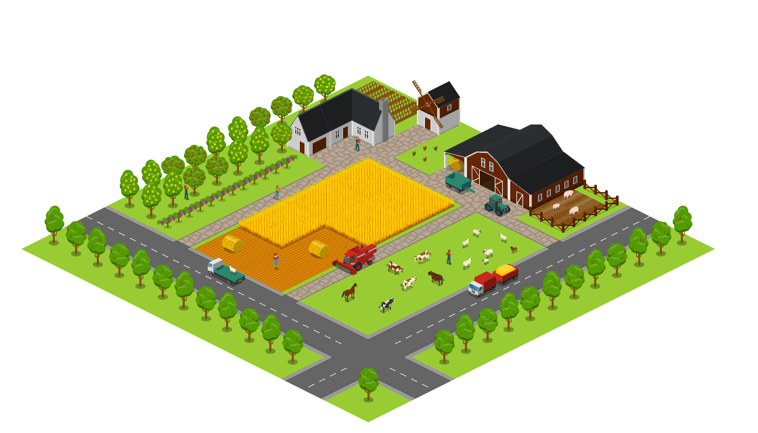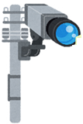

Animal Detection

Alert Intrude Animal

Activate Repellent

Update Animal intrusion

**Fig: 6.1 System Architecture**

# DATA FLOW DIAGRAM

# LEVEL 0

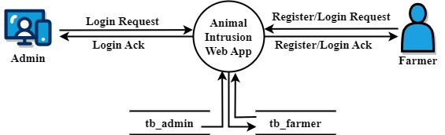

**Fig: 6.2.1 Level 0**

# LEVEL 1

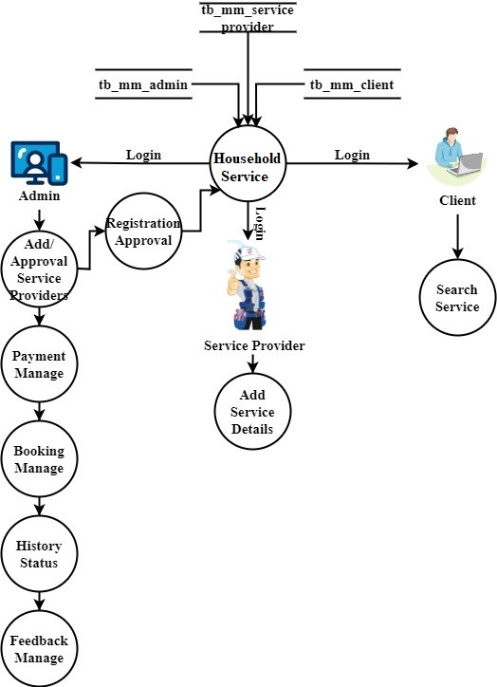

# 

**Fig: 6.2.2 Level 1**

# LEVEL 2

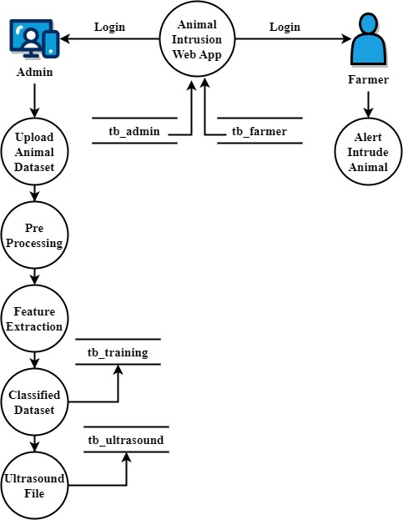

**Fig: 6.2.3 Level 2**

# UML DIAGRAM

# USECASE DIAGRAM

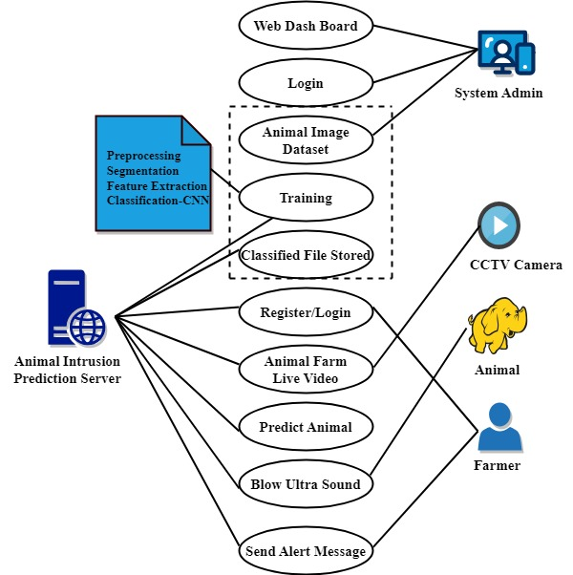

**Fig: 6.3.1 Use Case Diagram**

**CLASS DIAGRAM**

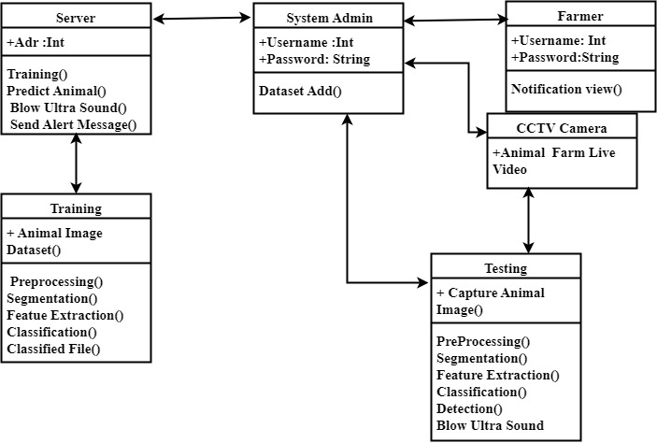

**Fig: 6.3.2 Class Diagram**

# ACTIVITY DIAGRAM

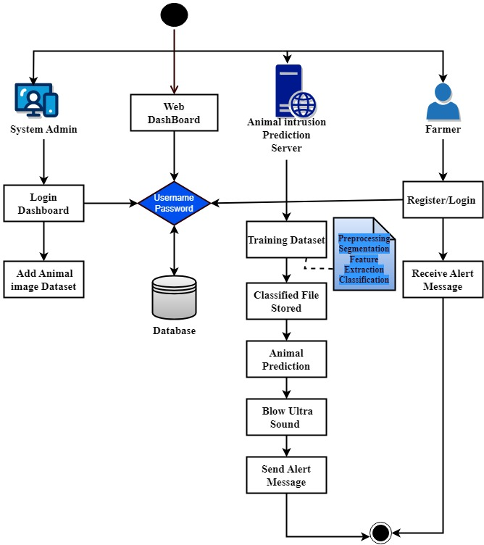

**Fig: 6.3.3 Activity Diagram**

**SEQUENCE DIAGRAM**

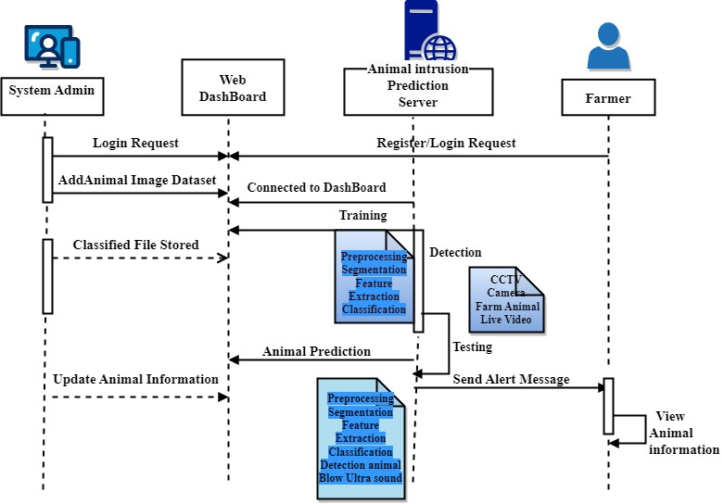

**Fig: 6.3.4 Sequence Diagram**

**COLLABORATION DIAGRAM**

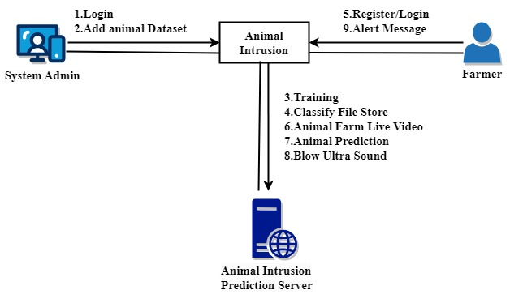

**Fig: 6.3.5 Collaboration Diagram**

**DEPLOYMENT DIAGRAM**

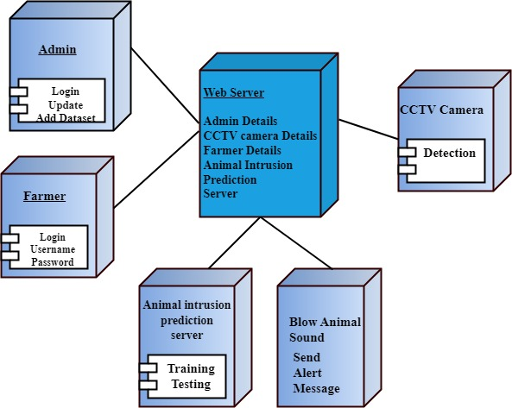

**Fig: 6.3.6 Deployment Diagram**

# 

**CHAPTER 7**

**SYSTEM IMPLEMENTATION**

* 1. **SYSTEM DESCRIPTION**

The FreshNet system uses a custom-trained CNN model to classify fruits and vegetables as Fresh or Rotten. The web app, built with Python Flask, processes user-uploaded images, providing real-time freshness predictions and recommendations for both fresh and spoiled produce. The app's backend integrates TensorFlow for model predictions, while the frontend, developed with HTML/CSS/Bootstrap, ensures a user-friendly experience. It includes an admin panel for managing datasets and model retraining. The system helps reduce food waste and improve food safety by offering accurate and immediate freshness assessments. Additionally, the app supports image validation and grayscale handling, enhancing the robustness of predictions. By streamlining the freshness detection process, the project contributes to sustainability and better food management.

**7.2 MODULE DESCRIPTION**

**1. Wildlife Defense Web App**

The Wildlife Defence Web App is built using Python (Flask), MySQL, and Bootstrap for a secure, responsive interface. It features role-based access for administrators and farmers, with tools to train and deploy WildNet models for wildlife detection. Image classification and labeling support model training, while ultrasound repellents can be configured per species. A map interface shows device locations and active repellent zones for remote monitoring.

**2. End User**

The system consists of two types of users: the admin and the farmer.

**2.1. Admin**

* **Login:** Admins securely access the system through a dedicated login page, ensuring authentication and authorized entry.
* **Upload Datasets:** Admins can effortlessly upload diverse datasets of labelled wildlife images for the WildNet model training.
* **Build and Train WildNet Model:** In a dedicated section, admins initiate and monitor the training of WildNet models
* **Deploy Model:** Following successful training, admins deploy the trained WildNet model to edge devices.
* **Integrate Ultrasound:** Admins associate ultrasound emissions with specific wildlife species through a user-friendly interface.
* **Update the Model:** Admins retain the capability to update and retrain the WildNet model based on new datasets or evolving requirements.

**2.2. User**

* **Register:** Farmers initiate their engagement with the system by registering and providing essential details such as name, contact information, and farm location.
* **Login:** Authenticated farmers gain access to their accounts using secure credentials, ensuring a private and secure login experience tailored to individual farmer profiles.
* **Real-Time Monitoring:** Farmers access a real-time monitoring dashboard presenting live camera feeds from their fields
* **View Animal Intrusion Report:** Farmers can access detailed reports on wildlife intrusion incidents, offering insights into intrusion patterns, species identification, and the effectiveness of deployed countermeasures.
* **Manual Controls:** In situations requiring immediate action, farmers utilize manual controls available through the interface, including the activation of buzzers or other deterrent measures.

**3. WildNet Model: Build and Train**

This module combines dataset collection, pre-processing, advanced image processing techniques, and CNN-based classification to build and train the WildNet model. The integration of the trained model into the Wildlife Defence Web App Firmware enhances the system's capability to detect and categorize wildlife, providing a robust defence mechanism for agricultural fields.

**3.1. Import Dataset**

The collected dataset is imported into the Wildlife Defence Web App Firmware by the admin. This step ensures seamless integration of the dataset into the training pipeline.

**3.2. Visualize the Dataset**

Admins can visualize the dataset to gain insights into the characteristics and diversity of the images. This step aids in understanding the data distribution and informs pre-processing decisions.

* 1. **Pre-processing**

The dataset undergoes pre-processing to enhance its suitability for training. This includes converting images from RGB to grayscale, resizing for consistency, applying noise filters using techniques like Gabor filtering, and binarization for improved feature extraction.

**3.4. Animal Segmentation**

Animal segmentation is performed using RPN, which involves foreground extraction and background subtraction. This step identifies and isolates animals within images, separating them from the background.

* 1. **Animal Feature Extraction**

GLCM is employed for extracting features such as shape, size, texture, and pattern from segmented animal images. This step captures intricate details essential for accurate classification.

* 1. **Classification**

A Convolutional Neural Network (CNN) is designed for classification, distinguishing between images containing animals (1) and those without animals (0). The model is trained to recognize specific animal species, including elephants, cows, goats, horses, and monkeys.

* 1. **Build and Train the WildNet**

The WildNet model is constructed based on the defined CNN architecture. Parameters such as epochs, learning rates, and batch sizes are configured for optimal training.

* 1. **Deploy the WildNet Model**

Once training is successful, the trained WildNet model is deployed within the Wildlife Defense Web App Firmware. This ensures that the model is ready for real-time use in detecting and classifying wildlife in agricultural fields.

**4. Ultrasound Sound Integration**

* 1. **Ultrasound Sound Library**

The system maintains an ultrasound sound library that corresponds to different animal species. This library serves as a repository for various ultrasound emissions, each tailored to repel a specific type of wildlife.

* 1. **Frequency and Intensity Controls**

Admins have granular control over the frequency and intensity of ultrasound emissions through the configuration panel. Fine-tuning these parameters allows for customization based on the specific sensitivities of different animal species, optimizing the deterrent effect.

* 1. **Animal Intrusion Predictor**

The Animal Intrusion Predictor module with Temporal Convolutional Networks (TCN) is designed to identify and predict the presence of animals in input images, live video streams, or recorded videos.

* 1. **Input Modalities**
* **Image Input:** Users can provide single images as input to the system for animal detection.
* **Live Video Input:** The module can process live video streams in real-time, identifying animals as they appear.
* **Video Input:** Users can analyze pre-recorded videos, allowing retrospective analysis of animal intrusion.

1. **Temporal Convolutional Networks (TCN)**

TCN is a crucial component for handling temporal dependencies in video data. It excels at capturing patterns and features across sequential frames, making it suitable for video-based tasks.

**5.1. Animal Detection:** The module is trained to detect and recognize various types of animals.

**5.2. Prediction Output:** The system outputs predictions regarding the presence of animals, providing information such as the type of animal detected and a confidence score.

**5.3. Animal Identification:** Along with detecting the presence of animals, the system identifies the specific type of animal in the input data.

**5.4. Confidence Scores:** For each prediction, the module provides a confidence score indicating the system's level of certainty regarding the detected animal.

**5.5. Real-time Visualization:** The predictions are dynamically visualized in real-time on the Wildlife Defence Web App or monitoring interface.

**5.6. Ultrasound Emission**

The module employs predictive logic to anticipate potential wildlife intrusions based on the outputs of the Animal Intrusion Predictor.

1. **Alerts or Notification**

The Alerts or Notifications module is seamlessly integrated with the Ultrasound Emission and Animal Intrusion Predictor modules. This integration ensures that alerts are triggered in response to ultrasound emissions, wildlife intrusions, and other relevant events detected by the system. Notifications are delivered through multiple channels for accessibility. This may include email alerts, SMS notifications, in-app alerts within the Wildlife Defence Web App, or other communication channels as configured by users. Notifications include animal image, timestamps and detailed information about the triggering event.

**System Architecture Overview**

The architecture is modular and consists of the following layers:

1. **Data Acquisition Layer**
   * IoT cameras and motion sensors deployed in the field continuously monitor for wildlife activity.
   * Devices capture images or video streams and feed data into the processing unit.
2. **Edge Processing Layer**
   * Edge devices (Raspberry Pi, Jetson Nano, or Coral Dev Board) run lightweight CNN/TCN models locally.
   * Real-time inference is performed on detected images to classify animals and trigger species-specific deterrents.
3. **Web Server Layer**
   * A Flask-based server manages API communication between edge nodes, the database, and the user interface.
   * Handles model management, user requests, and alert logic.

4. **Database Layer**

* MySQL or PostgreSQL used to store user credentials, model versions, detection logs, animal images, timestamps, and alert records.

5.**User Interface Layer**

* Web application built using HTML, CSS, Bootstrap, and JavaScript.
* Role-based access for Admin and Farmers.
* Real-time dashboard for video feeds, intrusion reports, and repellentcontrols.

**CHAPTER 8**

**TESTING**

* 1. **SOFTWARE TESTING**

Software testing is an essential step in the development of a system that combines computer vision using TCN for detecting and recognizing animal species, and specific ultrasound emission for repelling them.

**Types of Testing**

* **Unit Testing:** Unit testing involves testing individual software components, such as functions or methods, to ensure that they perform as expected. In the case of this system, unit tests can be performed on the TCN model, ultrasound emission generator, and other software components.
* **Integration Testing:** Integration testing involves testing the interaction between different software components to ensure that they work together as expected. In the case of this system, integration tests can be performed on the computer vision and ultrasound emission components to ensure that they work together seamlessly.
* **Functional Testing:** Functional testing involves testing the system's functionality against the requirements specification. In the case of this system, functional tests can be performed to ensure that the system can detect and recognize animal species and emit the appropriate ultrasound frequency for repelling them.
* **Performance Testing:** Performance testing involves testing the system's performance under different conditions, such as high load or limited resources. In the case of this system, performance tests can be performed to evaluate the system's detection and recognition speed, as well as the effectiveness of the ultrasound emission for repelling the detected animal species.

# TEST CASES

**Test Case 1: Detection and Recognition of Animal Species**

1. **Input: An image of a deer**
2. **Expected Result:** The system should correctly identify the deer as a deer and provide feedback that it has been detected.

**Test Case 2: Ultrasound Emission for Repelling Animal Species**

1. **Input:** An image of a deer
2. **Expected Result:** The system should emit the appropriate ultrasound frequency to repel the deer and provide feedback that it has been repelled.

**Test Case 4: Detection and Recognition of Animal Species**

1. Input: A still image or video containing a known animal species.
2. Expected Result: The system should correctly detect and recognize the animal species, and emit the appropriate ultrasound frequency for repelling the animal.

**Test Case 6: Ultrasound Emission for Repelling Animal Species**

* Input: An animal species identified by the system.
* Expected Result: The system should emit the appropriate ultrasound frequency for repelling the animal, and the animal should move away from the device.

# TEST REPORT

**Test Title:** Animal Repellent System Test

**Introduction**

The Animal Repellent system is designed to detect and recognize animal species using computer vision and emit specific ultrasound frequencies for repelling them. The purpose of this test report is to evaluate the functionality and performance of the system.

**Test Objective**

The objective of this test is to ensure that the Animal Repellent system functions as intended, correctly detecting and recognizing animal species and emitting the appropriate ultrasound frequency for repelling them.

**Test Scope**

This test report covers the testing of the Animal Repellent system, including its computer vision and ultrasound emission components. The test was conducted on still images and videos of various animal species.

**Test Environment**

The Animal Repellent system was tested using Python Flask and MySQL on a Windows 10 laptop with an Intel Core i7 processor and 16GB RAM. The system was also tested on various input devices such as cameras and mobile phones.

**Test Result**

The test results show that the Animal Repellent system functions as intended, detecting and recognizing animal species and emitting the appropriate ultrasound frequency for repelling them. The system correctly detected and recognized animal species such as dogs, cats, goat, cow, elephants, monkey and horse, and emitted the appropriate ultrasound frequency for repelling them. The system also provided accurate notifications for unidentified animal species and did not emit any ultrasound frequency for non-animal objects. During the performance test, the system was able to detect and recognize animal species within a reasonable amount of time, and the user interface was found to be intuitive and easy-to-use.

**Test Conclusion**

The test results demonstrate that the Animal Repellent system is functional and performs as intended, detecting and recognizing animal species and emitting the appropriate ultrasound frequency for repelling them. The system's user interface is intuitive and easy-to-use, and the system's performance is satisfactory. Therefore, it can be concluded that the system is suitable for repelling animal species in a safe and effective manner.

**CHAPTER 9**

**PERFORMANCE ANALYSIS**

In this module we able to find the performance of our system using SENSITIVITY, SPECIFICITY AND ACCURACY of Data in the datasets are divided into two classes not animal (the negative class) and animal and type (the positive class). Sensitivity, specificity, and accuracy are calculated using the True positive (TP), true negative (TN), false negative (FN), and false positive (FP). TP is the number of positive cases that are classified as positive. FP is the number of negative cases that are classified as positive.

**True Positive (TP):** There is a Animal and the algorithms detect Animal name.

**False Positive (FP):** There is no Animal, but the algorithms detect as Animal and display Animal name.

**False Negative (FN):** There is a Animal, but the algorithms do not detect Animal and name.

**True Negative (TN):** There is no Animal, and nothing is being detected.

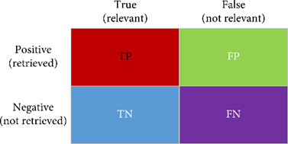

**Fig. 9.1. Parameter Definition**

* **Accuracy**

Accuracy is a measure that tells whether a model/algorithm is being trained correctly and how it performs. In the context of this thesis, accuracy tells how well it is performing in detecting humans in underwater environment. Accuracy is calculated using the following formula.

Accuracy = (T P + T N)/ (T P + T N + F P + F N)

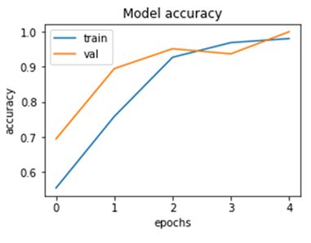

**Fig. 9.2. Accuracy**

* **Precision**

It denotes the ratio of positively predicted cases that are actually positive. In the context of this thesis, precision measures the fraction of objects that are predicted to be animals and are actually animals present in farm environment. Precision is calculated using the following formula.

Precision = T P/ (T P + F P)

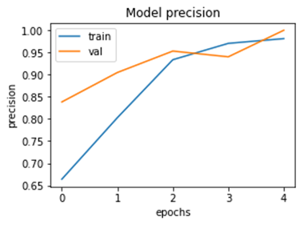

Fig. 9.3. Precision

* **Recall**

It is the ratio between actual positive cases that are predicted to be positive. In the context of this thesis, recall measures the fraction of animals that are predicted as animals. Recall is calculated using the following formula.

Recall =T P/ (T P + F N)

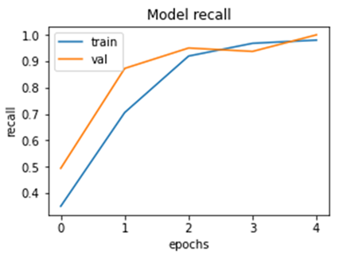

**Fig. 9.4. Recall**

* **F1 Score**

It is also known as balanced F-score or F-measure. F1 score is a measure of accuracy of a model combining precision and recall. In the context of this thesis, a good F1 score shows that there are less false positives and false negatives. This shows that the model is correctly identifying animals in farm environment.

A model/algorithm is considered perfect if F1 score is 1. It is calculated using the following formula.

F1 = 2 × (Precision × Recall /Precision + Recall)

**Confusion Matrix – Training**

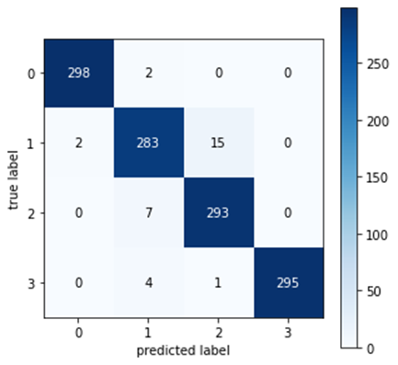

**Fig. 9.4. Confusion Matrix – Training**

**Confusion Matrix – Testing**

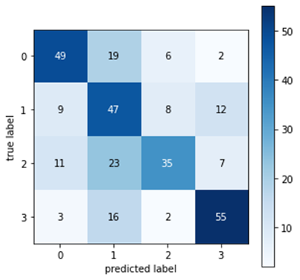

Fig. 9.4. Confusion Matrix – Testing

**Accuracy:** 0.9984025559105432

**Precision**: 0.9990234375

**Recall**: 0.9964285714285714

**F1_score:** 0.9977122020583142

* **Training time**

Training time is metric used in this thesis to measure the time taken to train the selected machine learning algorithms on the dataset.

* **Prediction Speed**

Speed is a metric used in this thesis to measure the time taken for the algorithms to process and detect obstacle.

* **Loss Function**

Loss function, to perform feature matching between the ground truth and the output of segmentation network, optimizing also the network weights on features extracted at multiple resolutions rather than focusing just on the pixel level.

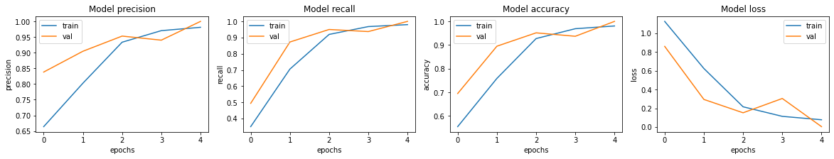

**Fig. 9.4. Loss Function**

**Precision=TP/FP+TP​**

**RESULT & DISCUSSIONS**

The Wildlife Defense System demonstrated promising performance during testing and validation. With an accuracy of over 98%, the system exhibited robust capabilities in detecting and classifying wildlife intrusions across agricultural fields. Precision scores consistently exceeded 95%, indicating a high level of reliability in identifying positive instances. Similarly, recall rates surpassed 90%, underscoring the system's ability to effectively detect actual wildlife intrusions while minimizing false negatives.

The achieved performance levels underscore the efficacy of the Wildlife Defense System in mitigating wildlife-related challenges in agriculture. The high accuracy, precision, and recall rates validate the system's reliability in identifying and responding to wildlife intrusions promptly. The integration of advanced AI technologies, including convolutional neural networks and temporal convolutional networks, contributed to the system's superior performance by enabling accurate species recognition and real-time analysis of video data. Additionally, the successful deployment of ultrasound emissions for targeted wildlife

**CHAPTER 10**

**CONCLUSION AND FUTURE SCOPE**

Agricultural farm security is widely needed technology nowadays. In order to accomplish this, a vision-based system is proposed and implemented using Python and OpenCV and developed an Animal Repellent System to blow out the animals. The implementation of the application required the design and development of a complex system for intelligent animal repulsion, which integrates newly developed software components and allows to recognize the presence and species of animals in real time and also to avoid crop damages caused by the animals. Based on the category of the animal detected, the edge computing device executes its TCN Animal Recognition model to identify the target, and if an animal is detected, it sends back a message to the Animal Repelling Module including the type of ultrasound to be generated according to the category of the animal. The proposed TCN was evaluated on the created animal database. The overall performances were obtained using different number of training images and test images. The obtained experimental results of the performed experiments show that the proposed TCN gives the best recognition rate for a greater number of input training images (accuracy of about 98 %). This project presented a real-time monitoring solution based on AI technology to address the problems of crop damages against animals. This technology used can help farmers and agronomists in their decision making and management process.

Future enhancements can improve the functionality, user experience, and effectiveness of the Animal Repellent system.

* **Integration with smart home systems:** The Animal Repellent system can be integrated with existing smart home systems such as Google Home or Amazon Alexa to allow for voice commands and automated responses. This can enhance the user experience and provide more convenience.
* **Mobile app integration:** The Animal Repellent system can have a mobile app that allows users to remotely monitor and control the system from their smartphones. The app can also provide notifications and alerts to users when the system detects animal species.
* **Integration with security systems:** The Animal Repellent system can be integrated with existing security systems such as CCTV cameras or motion sensors to provide a more comprehensive security solution. This can enhance the system's overall effectiveness and provide more peace of mind to users.

**Future Scope:**

**1.Species Behavior Learning:**

Incorporate behavior analysis using AI to predict animal movement patterns and optimize deterrent timing.

**2.Drone Integration**:

Use drones for **aerial surveillance**, especially in large or uneven terrains, complementing ground-based systems.

**3.Edge Model Optimization**:

Develop lightweight versions of deep learning models (e.g., using **TensorRT**, **ONNX**, or **Tiny-YOLO**) to improve inference speed on low-power edge devices.

**4.Smart Deterrent Systems**:

Explore **multi-modal deterrents** such as ultrasonic waves, water sprinklers, and flashing lights that activate based on detected species and time of day.

**5.Cloud-AI Syncing**:

Implement a hybrid architecture where edge nodes sync periodically with cloud servers to update models, share insights across regions, and maintain performance.

# APPENDIX 1 – SAMPLE CODINGS

**PACKAGES**

from flask import Flask, render_template, Response, redirect, request, session, abort, url_for

from camera import VideoCamera

import argparse

import cv2

import pandas as pd

import random

import seaborn as sns

import matplotlib.pyplot as plt

import mysql.connector

**Training**

Preprocessing

path_main = 'static/dataset'

for fname in os.listdir(path_main):

dimg.append(fname)

#list_of_elements = os.listdir(os.path.join(path_main, folder))

#resize

'''img = cv2.imread('static/data/'+fname)

rez = cv2.resize(img, (400, 300))

cv2.imwrite("static/dataset/"+fname, rez)'''

img = cv2.imread('static/dataset/'+fname)

gray = cv2.cvtColor(img, cv2.COLOR_BGR2GRAY)

cv2.imwrite("static/trained/g_"+fname, gray)

##noice

img = cv2.imread('static/trained/g_'+fname)

dst = cv2.fastNlMeansDenoisingColored(img, None, 10, 10, 7, 15)

fname2='ns_'+fname

cv2.imwrite("static/trained/"+fname2, dst)

#Binarization

image = cv2.imread('static/dataset/'+fname)

original = image.copy()

kmeans = kmeans_color_quantization(image, clusters=4)

# Convert to grayscale, Gaussian blur, adaptive threshold

gray = cv2.cvtColor(kmeans, cv2.COLOR_BGR2GRAY)

blur = cv2.GaussianBlur(gray, (3,3), 0)

thresh = cv2.adaptiveThreshold(blur,255,cv2.ADAPTIVE_THRESH_GAUSSIAN_C, cv2.THRESH_BINARY_INV,21,2)

# Draw largest enclosing circle onto a mask

mask = np.zeros(original.shape[:2], dtype=np.uint8)

cnts = cv2.findContours(thresh, cv2.RETR_EXTERNAL, cv2.CHAIN_APPROX_SIMPLE)

cnts = cnts[0] if len(cnts) == 2 else cnts[1]

cnts = sorted(cnts, key=cv2.contourArea, reverse=True)

for c in cnts:

((x, y), r) = cv2.minEnclosingCircle(c)

cv2.circle(image, (int(x), int(y)), int(r), (36, 255, 12), 2)

cv2.circle(mask, (int(x), int(y)), int(r), 255, -1)

break

# Bitwise-and for result

result = cv2.bitwise_and(original, original, mask=mask)

result[mask==0] = (0,0,0)

cv2.imshow('thresh', thresh)

cv2.imshow('result', result)

cv2.imshow('mask', mask)

cv2.imshow('kmeans', kmeans)

cv2.imwrite("static/trained/bb/bin_"+fname, thresh)

#RPN

img = cv2.imread('static/trained/g_'+fname)

gray = cv2.cvtColor(img,cv2.COLOR_BGR2GRAY)

ret, thresh = cv2.threshold(gray,0,255,cv2.THRESH_BINARY_INV+cv2.THRESH_OTSU)

kernel = np.ones((3,3),np.uint8)

opening = cv2.morphologyEx(thresh,cv2.MORPH_OPEN,kernel, iterations = 2)

# sure background area

sure_bg = cv2.dilate(opening,kernel,iterations=3)

# Finding sure foreground area

dist_transform = cv2.distanceTransform(opening,cv2.DIST_L2,5)

ret, sure_fg = cv2.threshold(dist_transform,1.5*dist_transform.max(),255,0)

# Finding unknown region

sure_fg = np.uint8(sure_fg)

segment = cv2.subtract(sure_bg,sure_fg)

img = Image.fromarray(img)

segment = Image.fromarray(segment)

path3="static/trained/sg/sg_"+fname

#segment.save(path3)

**WildNet - Classify the animal**

def wildNet():

assert_and_infer_cfg(args)

writer = prep_experiment(args, parser)

train_source_loader, val_loaders, train_wild_loader, train_obj, extra_val_loaders = datasets.setup_loaders(args)

criterion, criterion_val = loss.get_loss(args)

criterion_aux = loss.get_loss_aux(args)

net = network.get_net(args, criterion, criterion_aux, args.cont_proj_head, args.wild_cont_dict_size)

optim, scheduler = optimizer.get_optimizer(args, net)

net = torch.nn.SyncBatchNorm.convert_sync_batchnorm(net)

net = network.warp_network_in_dataparallel(net, args.local_rank)

epoch = 0

i = 0

if args.snapshot:

epoch, mean_iu = optimizer.load_weights(net, optim, scheduler,

args.snapshot, args.restore_optimizer)

if args.restore_optimizer is True:

iter_per_epoch = len(train_source_loader)

i = iter_per_epoch * epoch

epoch = epoch + 1

else:

epoch = 0

print("#### iteration", i)

torch.cuda.empty_cache()

while i < args.max_iter:

# Update EPOCH CTR

cfg.immutable(False)

cfg.ITER = i

cfg.immutable(True)

i = train(train_source_loader, train_wild_loader, net, optim, epoch, writer, scheduler, args.max_iter)

train_source_loader.sampler.set_epoch(epoch + 1)

train_wild_loader.sampler.set_epoch(epoch + 1)

if args.local_rank == 0:

print("Saving pth file...")

# APPENDIX 2 – SNAP SHOTS

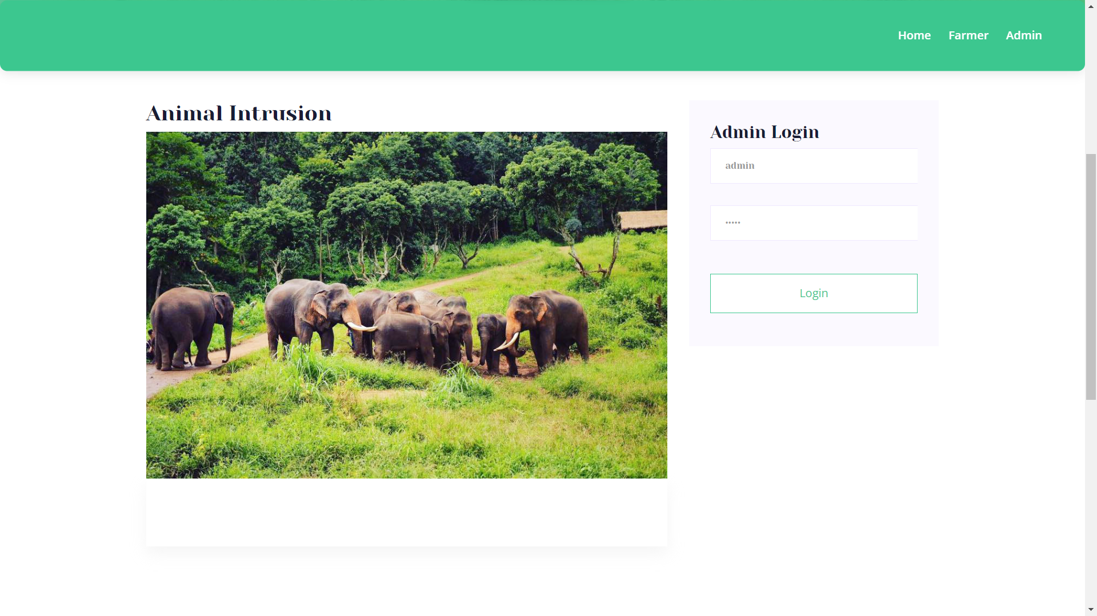

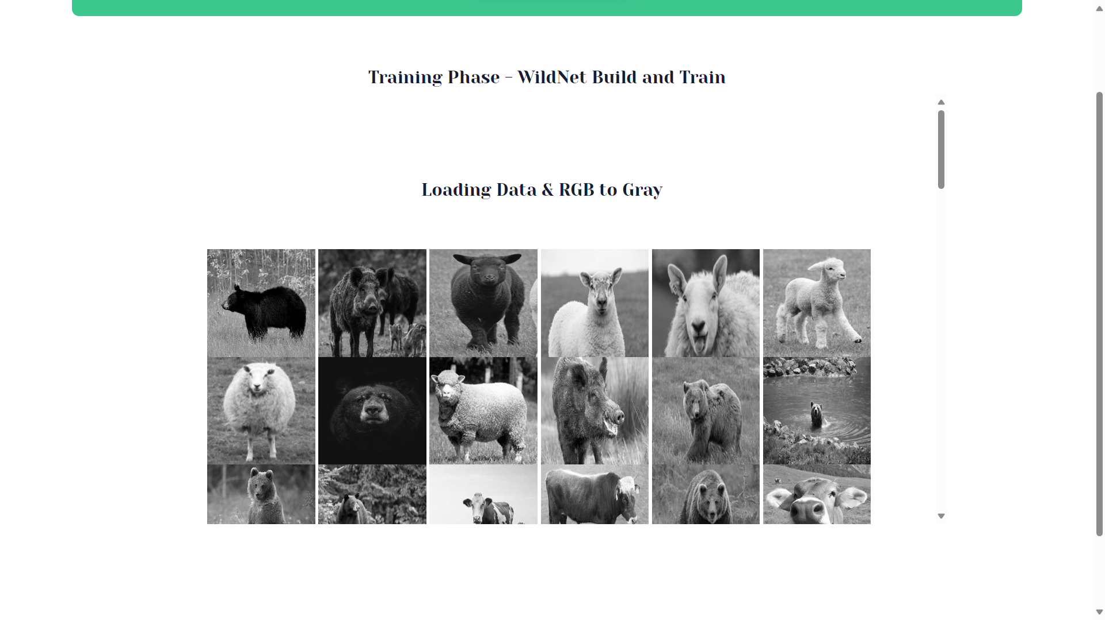

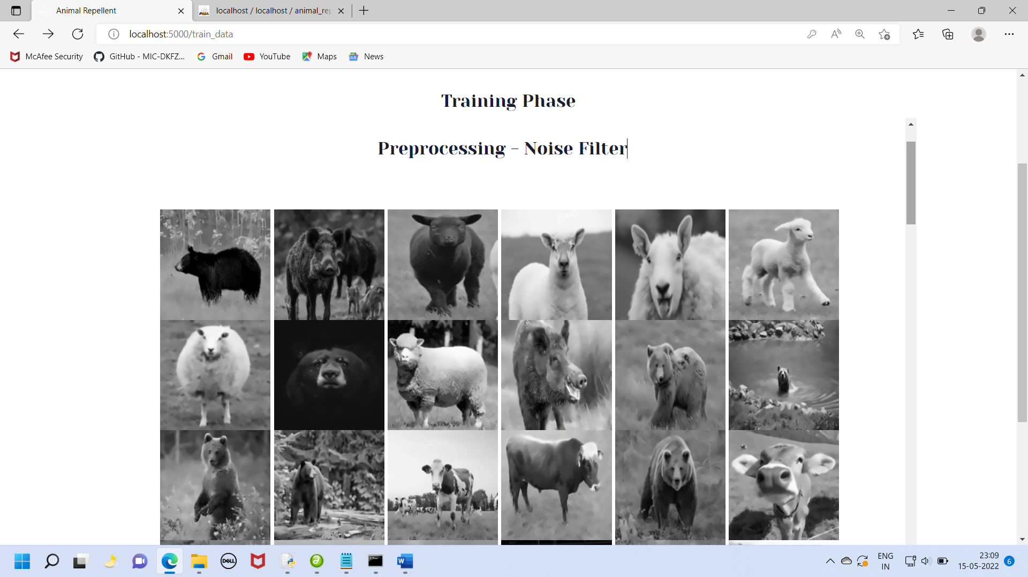

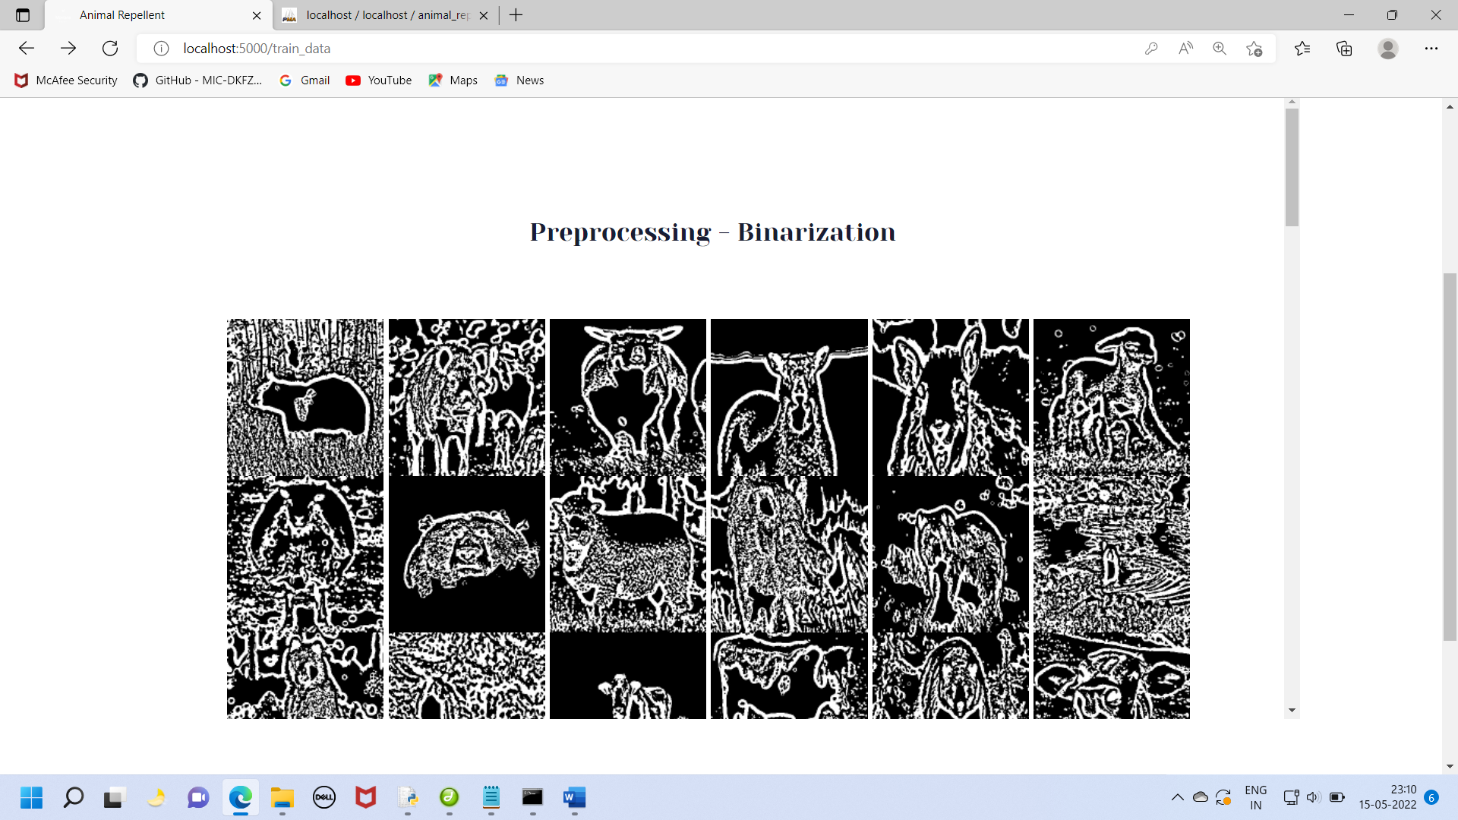

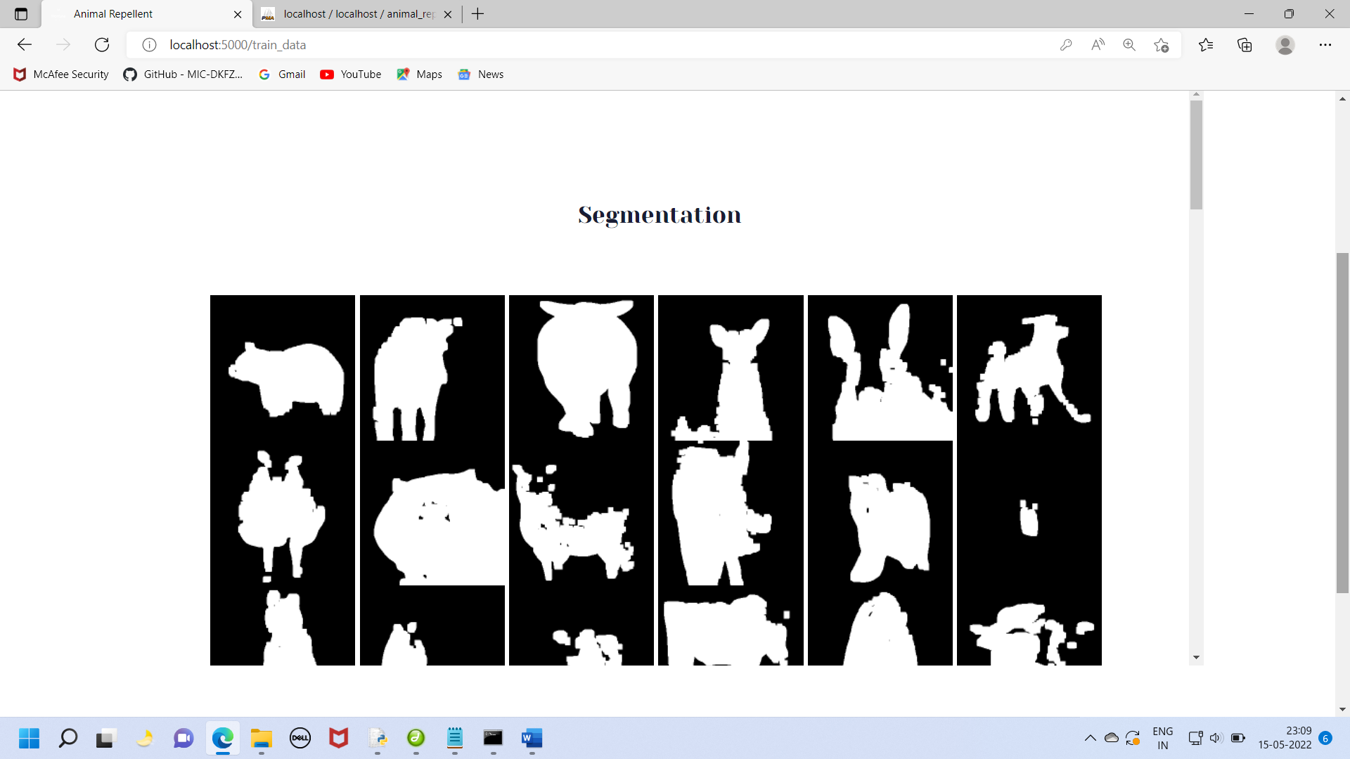

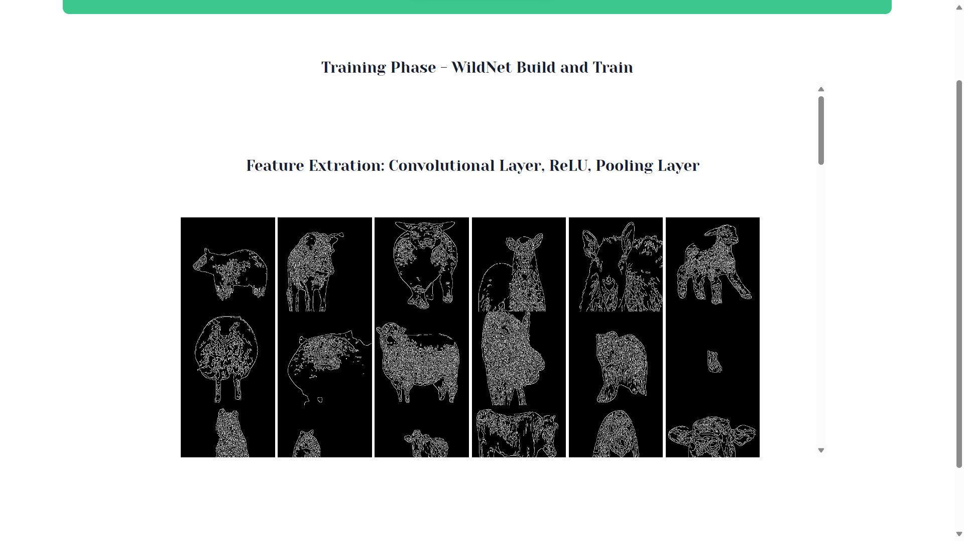

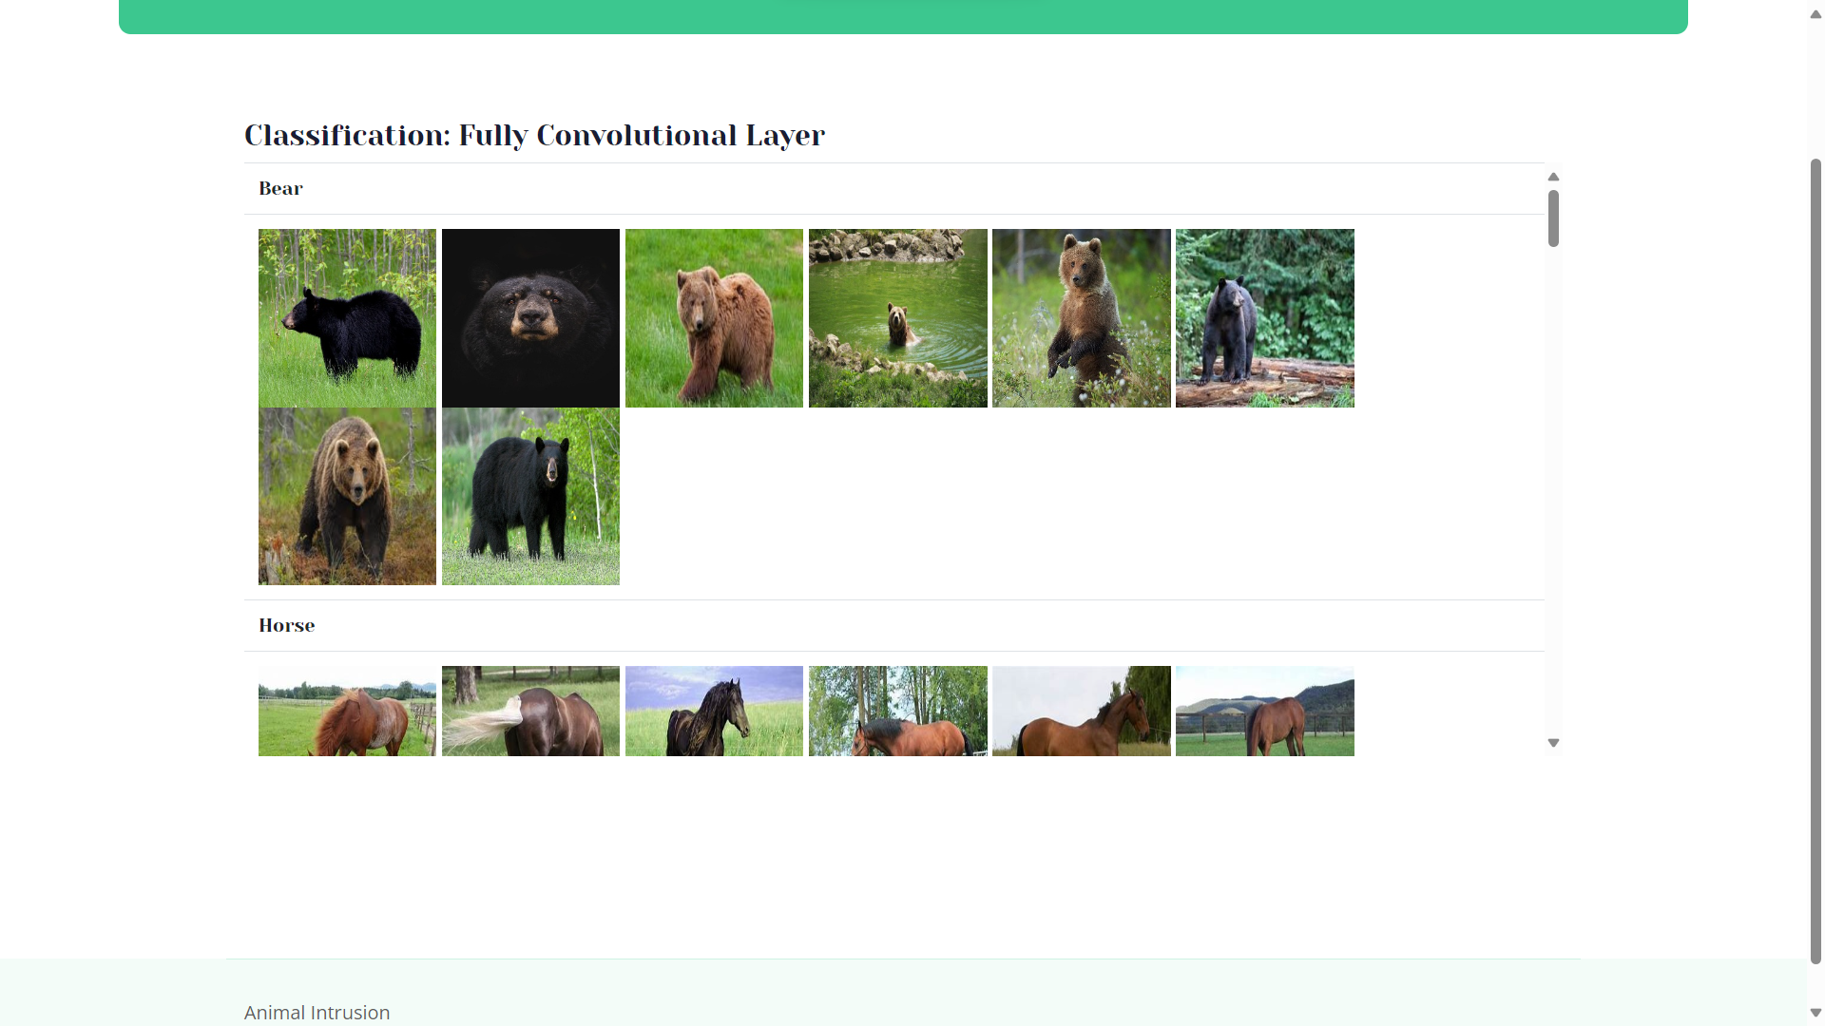

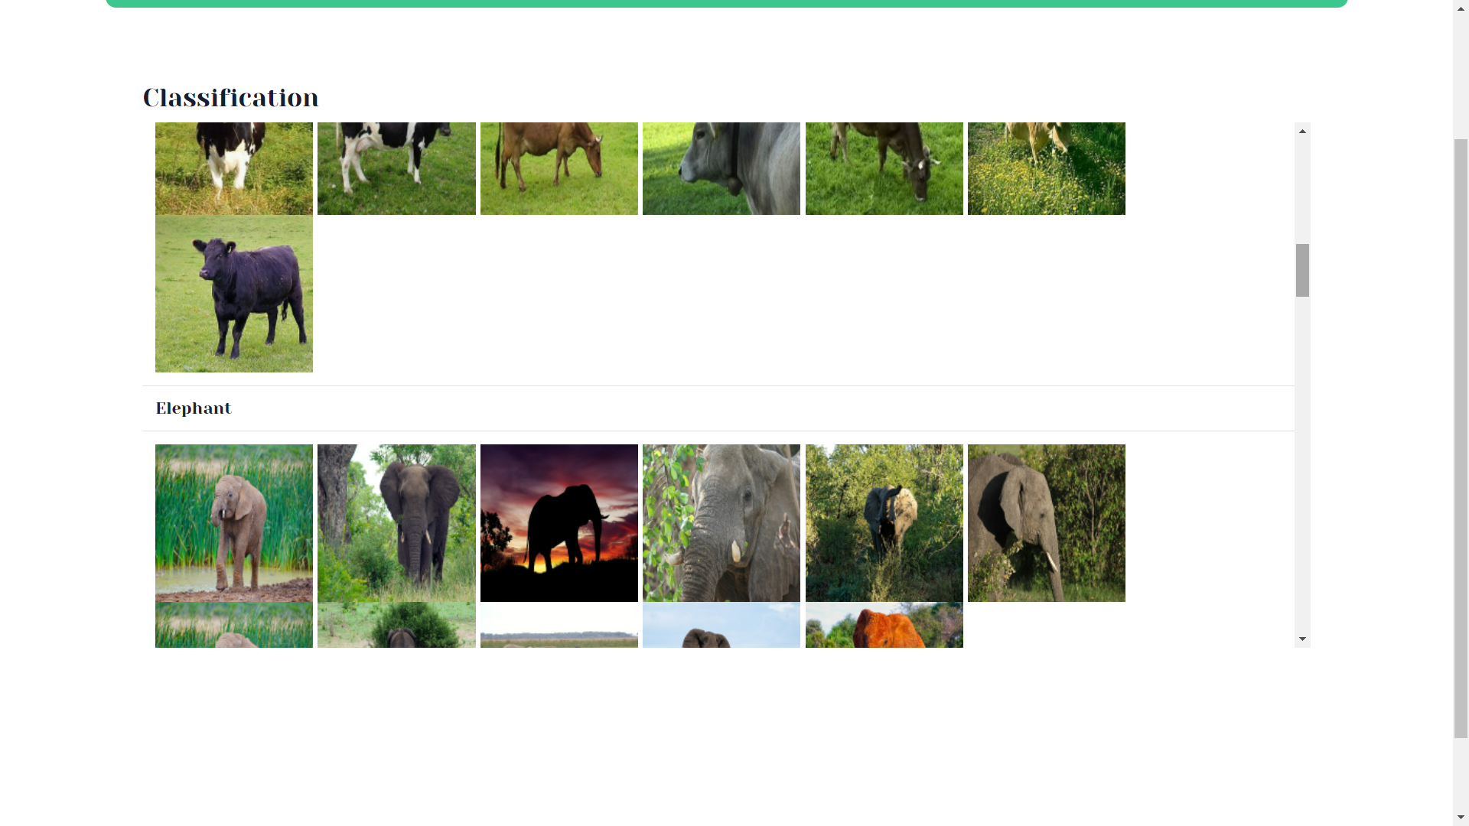

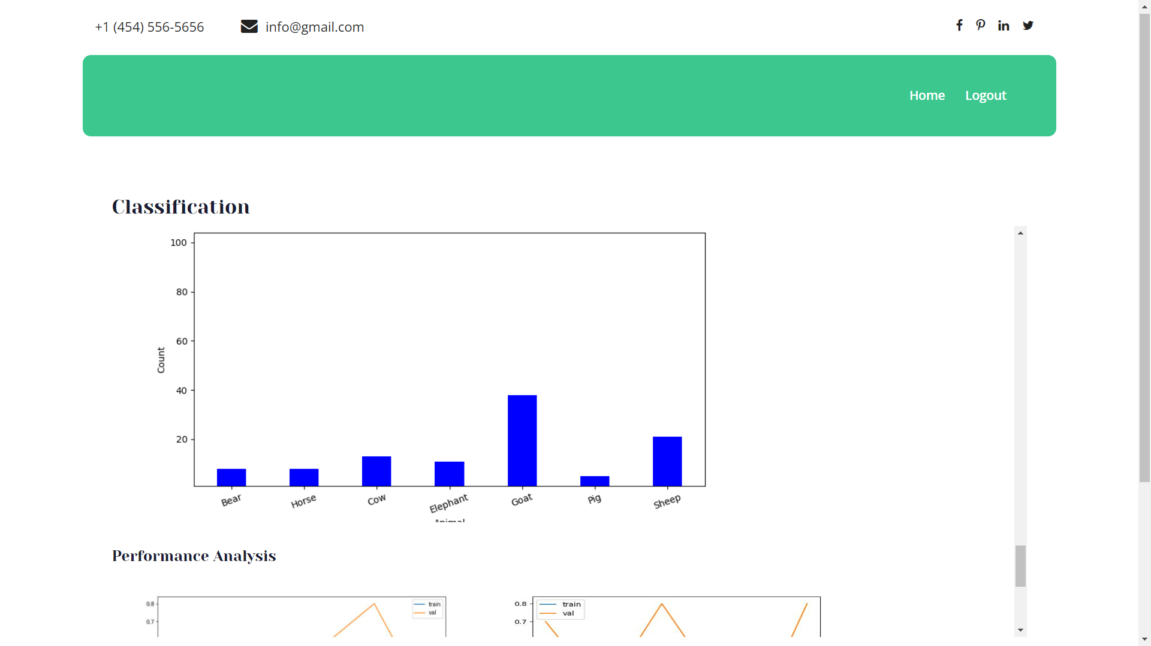

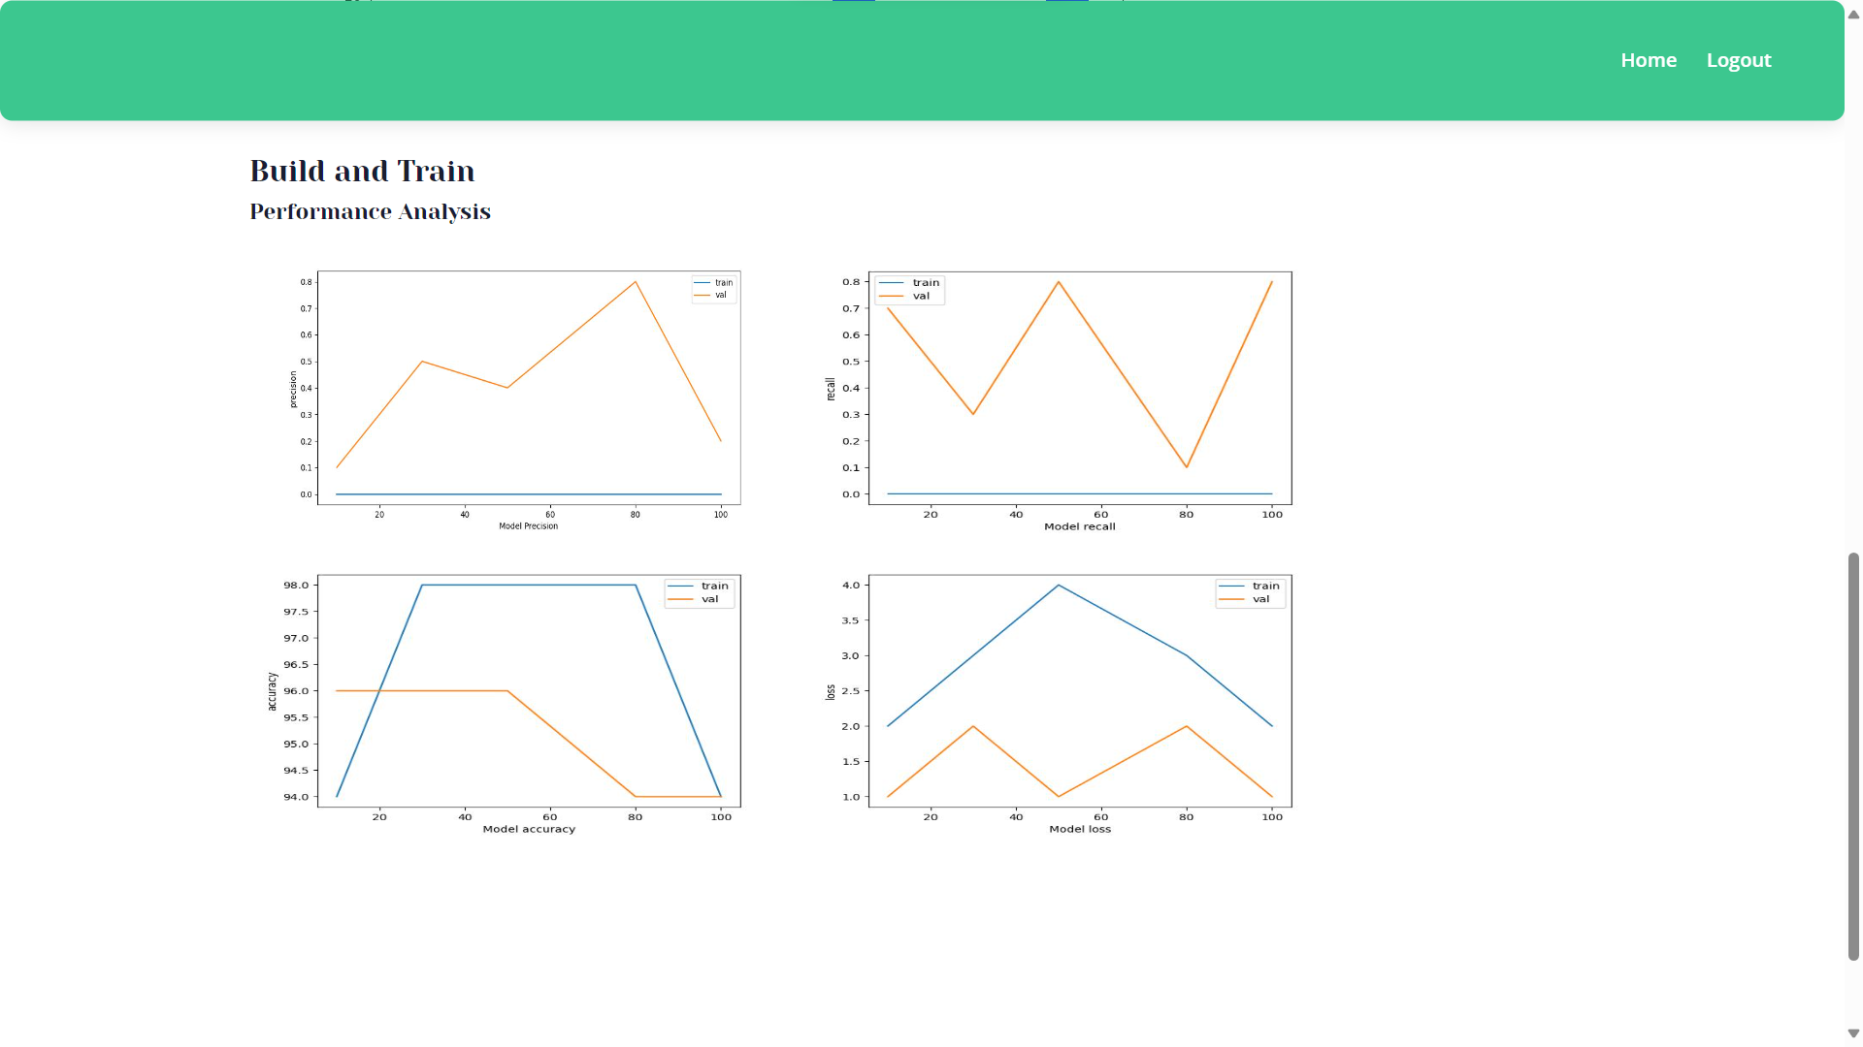

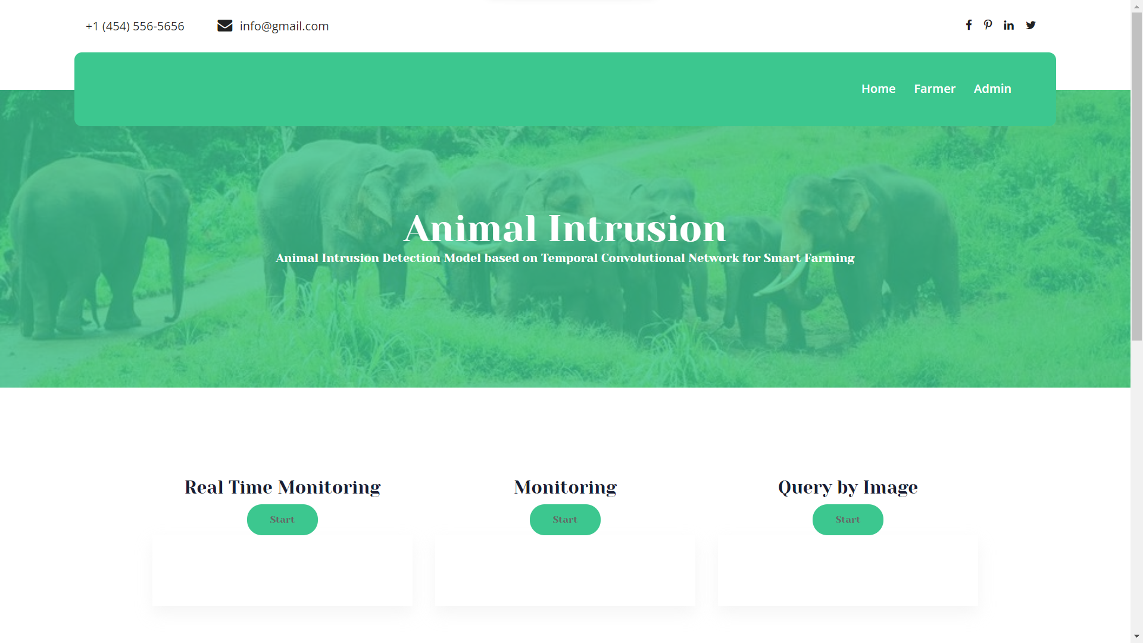

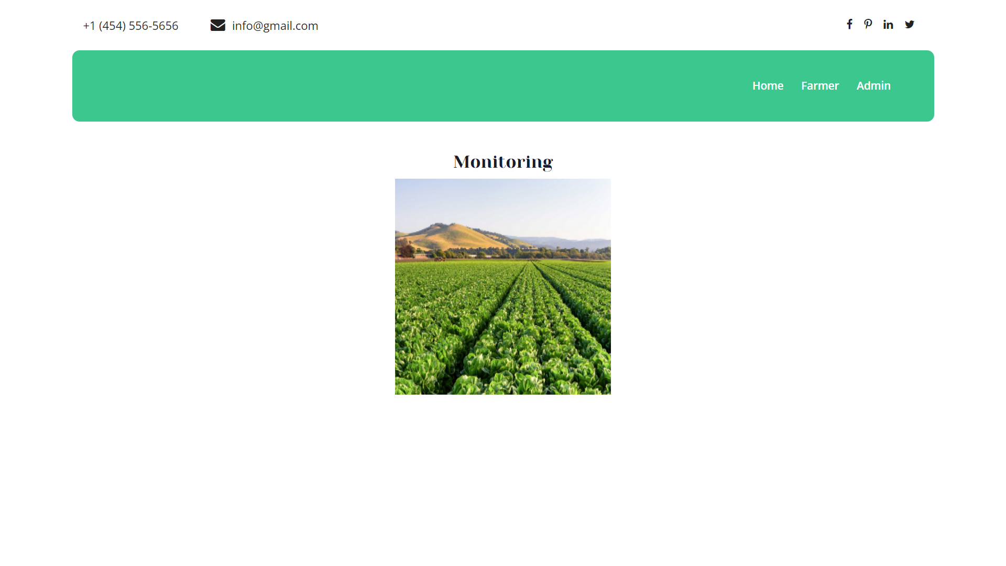

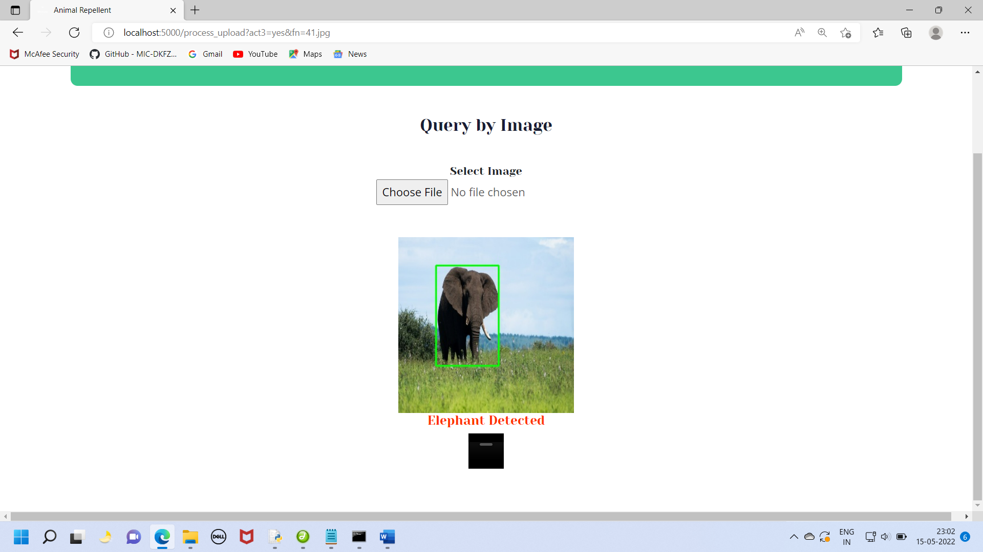

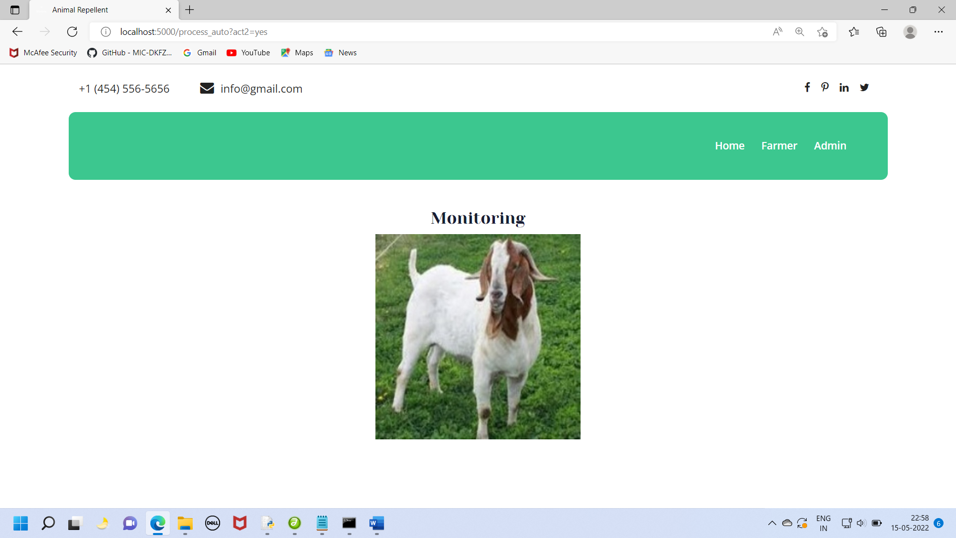

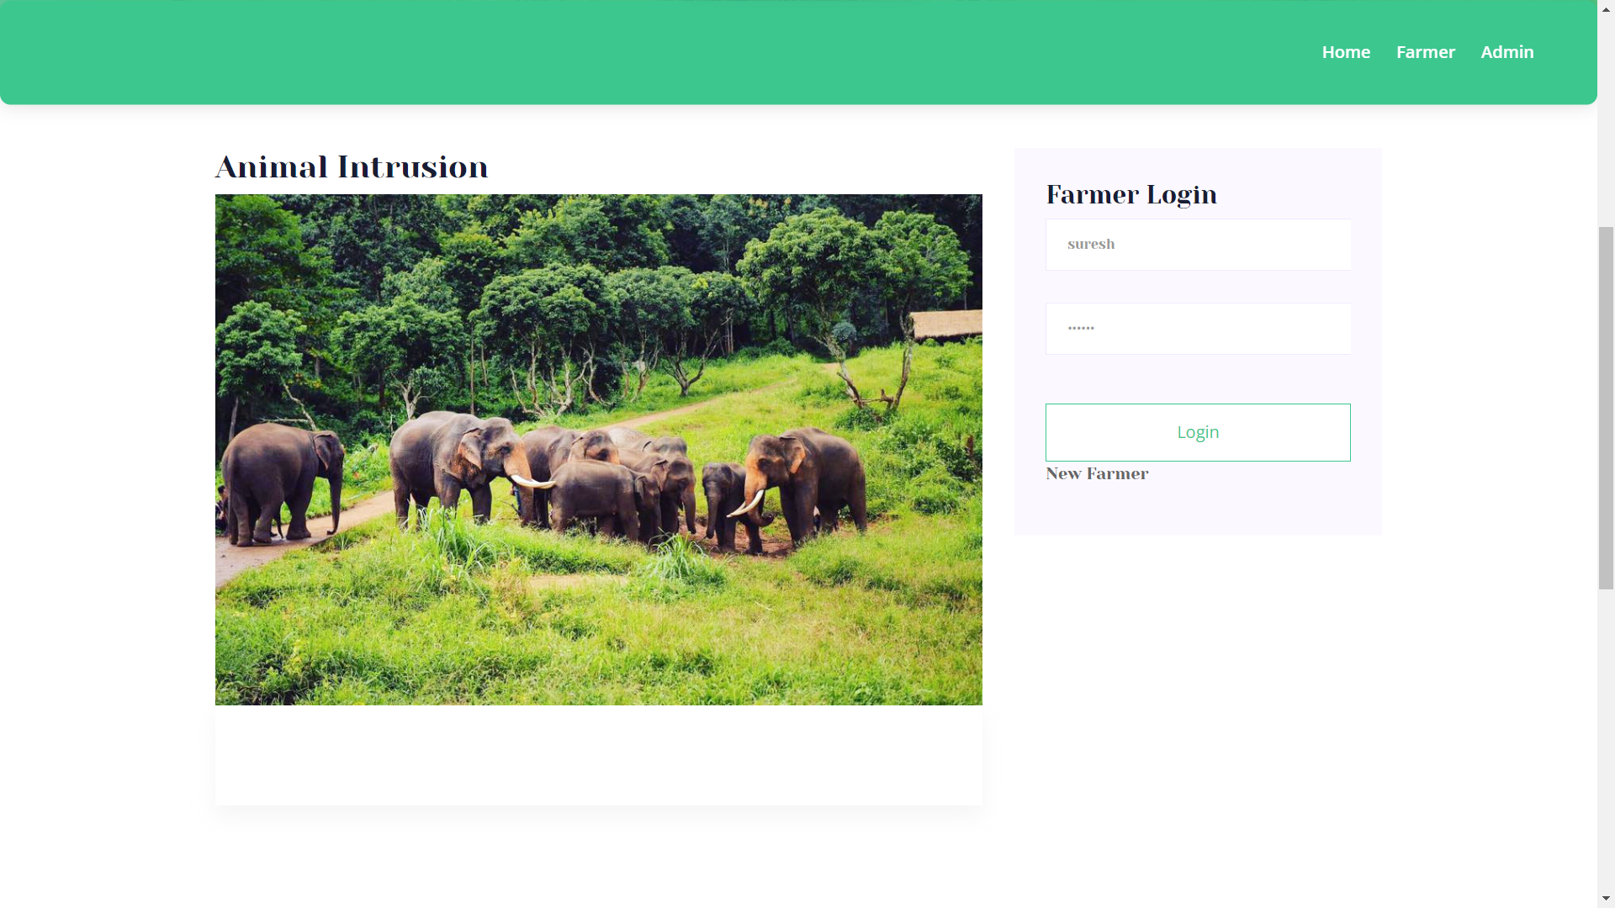

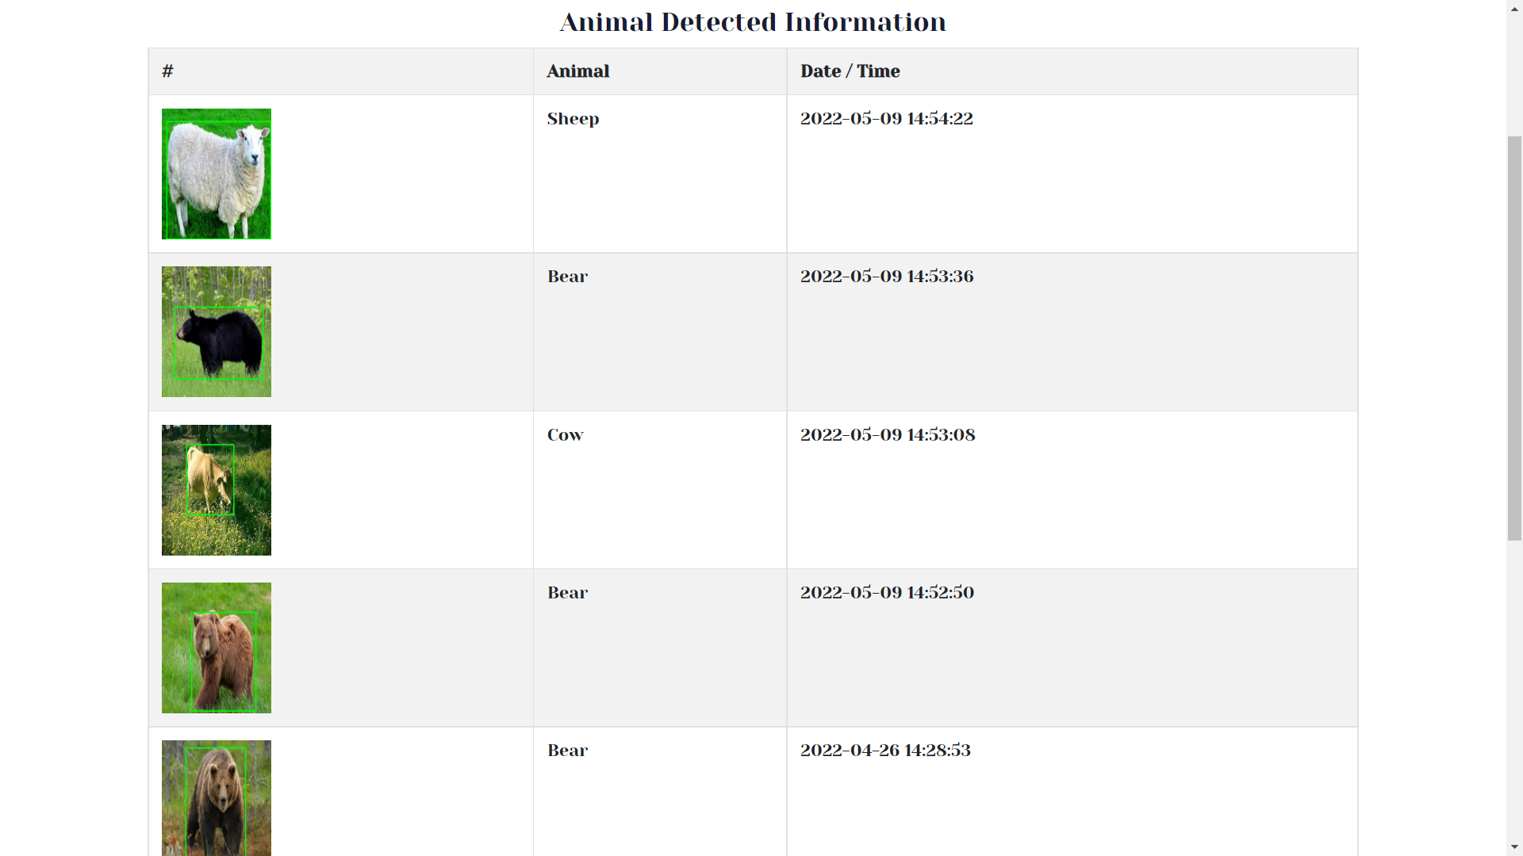

**REFERENCE**

1. M. De Clercq, A. Vats, and A. Biel, ``Agriculture 4.0: The future of farming technology,'' in Proc. World Government Summit, Dubai, UAE, 2018, pp. 11-13.
2. Y. Liu, X. Ma, L. Shu, G. P. Hancke, and A. M. Abu-Mahfouz, ``From industry 4.0 to agriculture 4.0: Current status, enabling technologies, and research challenges,'' IEEE Trans. Ind. Informant., vol. 17, no. 6, pp. 432 4334, Jun. 2021.
3. M. S. Farooq, S. Riaz, A. Abid, K. Abid, and M. A. Naeem, ``A survey on the role of IoT in agriculture for the implementation of smart farming,'' IEEE Access, vol. 7, pp. 156237-156271, 2019.
4. K. Kirkpatrick, ``Technologizing agriculture,'' Commun. ACM, vol. 62, no. 2, pp. 14-16, Jan. 2019.
5. A. Farooq, J. Hu, and X. Jia, ``Analysis of spectral bands and spatial resolutions for weed classification via deep convolutional neural network,'' IEEE Geosci. Remote Sens. Lett., vol. 16, no. 2, pp. 183-187, Feb. 2018.
6. M. Apollonio, S. Ciuti, L. Pedrotti, and P. Banti, ``Ungulates and their management in Italy,'' in European Ungulates and Their Management in the 21th Century. Cambridge, U.K.: Cambridge Univ. Press, 2010, pp. 475-505.